

Software Engineering Department

Braude College

Capstone Project Phase B

**Dog - Human Communication**

**Using Eye Tracker Technology**

Project code: 24-1-R-15

Supervisors:

Dr. Julia Sheidin

Dr. Samah Idrees-Ghazawi

Student:

Sara Asaad - [saraasaad5@gmail.com](mailto:saraasaad5@gmail.com)

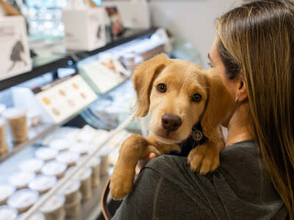

Table of Contents

Abstract 5

1. Introduction 5

2. Background and Related Work 6

2.1. Breed-Specific Changes Observed in Dogs 6

2.2. Eye Tracking Technology 7

2.3. Areas Of Interest (AOI's) 8

3. Research Process 9

4. Research Methodology 11

4.1. Dataset 11

4.2. Hypothesis 12

4.3. Experimental Parameters 13

4.4. Procedure 14

5. Results 16

5.1. The average number of visits to the images 16

5.2. The average amount of time spent looking at images 19

5.3. The average number of visits to the AOI's 21

5.4. The average amount of time spent looking at AOI's 24

5.5. Comparing perception and viewing 27

5.6 Analysis of the Dog's Presented Situation 32

5.7. Emotional Evaluations of Brachycephalic and Normocephalic Dogs 36

5.8. The relationship between increasing age and the ability to identify situations in a more negative way 40

5.9. Israel VS. Prague 42

6. Conclusion 46

7. Challenges 47

8. User Guide 48

9. Maintenance Guide 53

9.1. Connecting The Device 53

9.2. Calibration And Participants Setup 54

9.3. Inputting User Information and Setup for Data Collection 55

9.4. Response mechanism and stimulus display 55

9.5. Saving Data and Exporting Results 55

10. Future Work 56

11. Appendix 58

References 59

Table of Acronyms

|  |  |
| --- | --- |
| Acronym | Meaning or definition |
| AOI | Area of Interest |
| POI | Point of Interest |
| Tobii Pro Spark | A screen-based eye tracker captures gaze data at speeds up to 250 Hz. This powerful research system supports everything from fixation to saccade-based analyses. |
| Tobii Pro Lab | Tobii Pro Lab is an eye tracking software for behavior research. |
| Snout area | The front part of the dog's face, which includes the nose and mouth |

Link to the GIT folder:

https://github.com/SaraAs22/Final-Project..git

# Abstract

# Understanding a dog's emotions is crucial for several reasons, and it plays a significant role in responsible dog ownership. However, which parts of the animal's face are more informative to the observer in recognizing emotion is a problem that has not been fully researched. This research project aims to fill the gap by answering the following question: How can eye-tracking technology contribute to a deeper understanding of dogs and strengthen the connection between humans and dogs? To achieve this goal, we did research that uses eye-tracking technology and tracks the person's gaze for a dog image to understand if looking at a certain area improves the understanding of the dog's behavior. In this research, we aim to explore the feasibility of developing a system capable of identifying a dog's emotions by analyzing its movements and facial expressions. Leveraging advances in image technology and deep learning, this project can provide crucial milestones for the future development of such a system, facilitating thorough preparation and planning of the process. Analysis of eye-tracking data showed that participants spent more time on images of brachycephalic dogs compared to normocephalic dogs. There were also more visits to specific areas of brachycephalic dogs' faces. These results suggest that participants found it harder to interpret brachycephalic dogs' emotions, requiring more time and attention to understand their emotional states. This supports the idea that recognizing emotions in brachycephalic dogs is more challenging due to their unique facial and physical structure.

**Keywords: Eye tracker, Dog-human relationship, Dog's face, Dog's emotions, Area of Interest (AOI), Eye gaze.**

# 1. Introduction

Animals, particularly dogs, employ facial expressions and body language to maintain their social structure with humans [Bloom & Friedman, 2013]. Those facial expressions of emotion offer important visual indicators for understanding others' emotional states and intentions [Guo & Shaw, 2015]. Identifying and comprehending a dog’s emotions through areas in their faces is crucial since it can improve human communication with them [Eretová et al., 2024].

Dogs play various roles in human life, including companions, rescue, therapy, and medical. Therefore, they have shown remarkable abilities in interpreting human gestures and cues, but understanding dogs' emotions through human-directed visual communication remains limited. A lack of knowledge about breed-specific traits or common dog behaviors can make it difficult to effectively meet a dog's needs.

Previous studies have delved into the emotional facial expressions of dogs, shedding light on their behavior and communication cues [Eretová et al., 2024; Correia‐Caeiro et al., 2023; Bloom & Friedman, 2013]. Moreover, research conducted by Correia-Caeiro et al. 2023 demonstrated that the emotional expressions of dogs impact the duration of gaze directed towards particular facial regions in both children and adult humans, as evidenced in their previous study in 2020 [Correia-Caeiro et al., 2023; Correia-Caeiro et al., 2020]. Continuing this trajectory, our aim is to investigate whether individuals' focus on specific regions of a dog's face helps in comprehending its emotions. Given the challenge of precisely determining which part of the dog's face a person is observing and for how long, we intend to utilize gaze tracking technology for our research to understand if looking at a certain area improves the understanding of the dog's behavior. We aim to answer the following research question: How can eye-tracking technology contribute to a deeper understanding of dogs and strengthen the connection between humans and dogs?

Our research project aimed to use eye-tracking technology and Tobii Pro Lab software to display images of brachycephalic and normocephalic dogs with questions for each image. The software recorded the gaze behavior of the participants, focusing specifically on which areas of the dogs' faces they are looking at and for how long. The goal was to analyze whether the participants' focus on certain areas of interest in dog's face can give a more accurate answer to what the dog is feeling and in what situation it is. The system produced results in different visual formats to provide a clearer understanding of the eye movement patterns and insights of the participants derived from the research. Thus, the results can help us improve the relationship between humans and dogs.

# 2. Background and Related Work

## This section is organized as follows: we begin with a general overview of breed- specific differences in dogs. Following this, since our research explores how eye-tracking technology contributes to a deeper understanding of canine behavior and emotions, we will provide a concise explanation of eye-tracking technology and its relevance to our study.

## 2.1. Breed-Specific Changes Observed in Dogs

Evolutionary changes in facial muscles may enhance affectionate expressions. Modern dog breeds have extreme morphological changes, such as brachycephaly (‘shortened head’ dogs, the appearance of their head looks as if the skull is very compressed from front to back. Therefore, they appear flat with short noses[1], for example, see Fig. 1), which has negative consequences for dog welfare and health. Brachycephalic dogs may struggle with communication with humans due to their small tails, limited facial expressions, and difficulty in breathing. However, evidence on dog ownership status and the impact of age on recognizing canine cues is limited [Eretová et al., 2024].

  
 **Fig. 1:** Brachycephalic dog. **Fig. 2:** Non-brachycephalic dog.

In the context of brachycephalic dogs, research has specifically examined how their facial structure influences their visual signals and how humans interpret these cues, encompassing both facial expressions and body language. However, it's important to note certain limitations within the existing literature [Eretová et al., 2024]. For instance, some studies may have varied participant demographics regarding gender and age, potentially impacting the generalizability of the findings. Additionally, certain investigations may not have concentrated on a specific demographic or population subset, and sometimes, people do not report accurately or erroneously about the things they looked at due to various factors such as subconscious memory or external influences. All these could affect the depth of understanding in this area.

## 2.2. Eye Tracking Technology

For our project, we used Tobii Pro Spark[2] because it is designed for quick and easy setup. Attach by placing it under the screen for studies of real-world stimuli and simply connect to the computer via USB.

Tobii Pro Spark works with Tobii Pro Lab, supporting researchers from experiment design to data analysis. Eye-tracking metrics and visualizations help you understand participants’ visual attention and behavior more deeply. Using eye-tracking metrics and imaging to gain deeper insights into participants' behavior and visual experiences (for example, see Fig. 3).

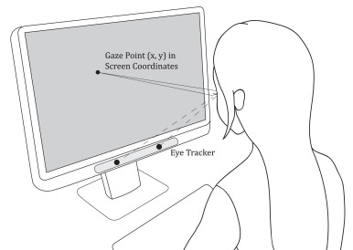

**Fig. 3:** How does the screen-based eye-tracking work [Liu et al., 2021].

## 2.3. Areas Of Interest (AOI's)

Refers to specific regions within an image or visual stimulus where participants' attention is measured. In eye-tracking studies, AOIs are used to focus on particular areas, such as the eyes, mouth, or other relevant features, to determine how much time or attention participants spend looking at them. By analyzing AOIs, we can gain insights into which parts of an image draw the most attention and are deemed most important for interpreting information.

In our study, the Areas of Interest (AOIs) encompassed key facial regions such as the eyes, ears, snout area, cheeks, and forehead.

The reasons for choosing these specific parts of the dog's face in our study are:

1. Reconstruction of a previous experiment: these parts were chosen in order to reproduce the original experiment [Eretová et al., 2024], in which the same areas of the dogs' faces were previously tested to understand how humans recognize emotions and expressions in dogs' faces. Reproducing the experiment allows comparison of results between the different populations, such as in Israel and Prague.
2. High relevance to emotion recognition: These parts of the dog's face are the parts that provide the clearest indications of canine emotions. For example, eye movements, ear position, and mouth expressions are indicators that are recognized as having a great impact on understanding the emotional state of the dog, so it is important to focus on them.

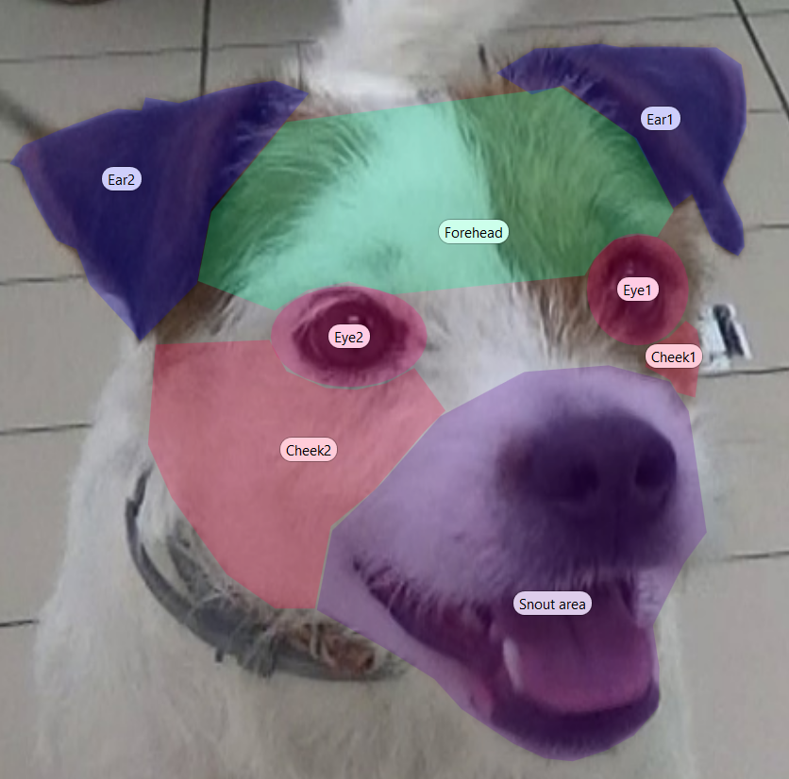

**Fig. 4:** Image of dog AOI's in our study.

# 3. Research Process

Our work process on the project began by getting to know the research field of "animal-computer interaction" and learning about the relationship between animals and people. As part of the learning process, we participated in an international workshop, "New Methods in Dog Behavior," held at the University of Haifa. This international workshop allowed researchers and practitioners working on dog behavior, cognition, and welfare to meet and exchange ideas.

Following the meeting and brainstorming session with Prof. Anna Zamansky, Head of "Tech4Animals" Lab at the University of Haifa, we decided to focus on investigating how eye-tracking technology could contribute to a deeper understanding of dogs and strengthen the connection between humans and dogs. Prof. Anna Zamansky introduced us to the research provided by the Czech University of Life Sciences in Prague [Eretová et al., 2024]. Then we decided to reproduce their experiment with the addition of the eye tracker technology.

As we delved into the realm of eye-tracking technology, we uncovered several works dealing with the face and emotion recognition of humans. Next, we checked if similar research was done in the field of face and emotion recognition of animals in general and dogs in particular. As a result of our learning, we progressed in understanding the dynamics of human-animal interaction, and we began delving into the mechanics of eye-tracking systems, such as software applications like Tobii Pro Spark and Tobii Pro Lab, to understand their functionality and potential applications. Next, we defined the methodology we would use for our research: a controlled experiment. Consequently, we defined the experiment, including the data set based on the Czech experiment and the gaze tracking technology.

Going forward, we researched a Tobii Pro Lab system equipped with an eye-tracker. This system helped us to present images featuring various breeds of dogs and ascertain the specific face areas the observer focused on, along with the duration of their gaze. We also planned to explore whether individuals' proficiency in interpreting these signals was influenced by their age. The system presents observation results in diverse visual formats to enhance comprehension of the findings.

As part of the experimental procedure, we provided a questionnaire to the participants through Tobii Pro Lab system, based on a previous study from which we drew inspiration. However, the questionnaire needed to be adapted to our needs of using eye-tracking technology. In addition, the questionnaire needed to be translated (to Hebrew).

Finally, we analyzed the results and examined the conclusions. To ensure reliable and accurate results, potential limitations, such as environmental conditions, had to be considered and resolved as much as possible. Also, attention was paid to planning the stages of the experiment, performing them in a planned order using a scientific method, and giving precise instructions to the participants in the experiment.

During the planning and execution of the experiment, I faced several dilemmas and iterations before finalizing the experiment's design. The initial idea was to present participants with a series of dog images and ask them to answer questions to identify the emotions expressed by the dog in each image. After viewing each image, participants would answer three questions before moving on to the next visual stimulus. My main challenge was determining the most effective way for participants to answer the questions: should the responses be made within the software itself or externally? If within the software, should the question appear as an image, and should the answer be selected using eye movements or keyboard input? Alternatively, I considered whether using a platform like Google Forms would be more efficient for capturing responses.

Based on a fruitful discussion with Nadav Schechter, Chief Executive Officer in NBT New Biotechnology Ltd, it was recommended that the questions be displayed directly on the screen within the experimental software (LAB). Participants could either look at the answer and press a key (such as the spacebar) to move forward, or select the correct answer with the mouse, triggering automatic progression.

After much thought and considering the requirements of our study, it became clear that it was more important to record where participants were looking and which areas of interest they focused on, rather than how they answered the questions. Since we would ultimately receive the answers through Google Forms, it was recommended to display the images directly on the screen within the experiment software (LAB) and use Google Forms to present the questions. Participants could answer the questions normally and press the F10 key to proceed from the questions to the next image. This way, eye movements could be recorded for later data analysis.

This approach offered the advantage of capturing eye-tracking data alongside participants' responses, providing richer data for analysis and ensuring a smoother experiment flow for our study.

The last step before analyzing the data was to meet with the Czech University of Life Sciences in Prague team [Eretová et al., 2024] and Prof. Anna Zamansky to show them the result of our experiment and make sure it follows their expectations and requirements. During that meeting, the team was satisfied with the experiment and suggested further collaborations.

# 4. Research Methodology

## In our study, we replicated the experiment on the effect of brachycephaly on visual signals in dogs [Eretová et al., 2024], with the addition of eye-tracking technology to record the participants' eye movements to dog images. We aimed to understand if looking at a certain area improved the understanding of the dog's behavior. 45 participants, most of them students from Braude College of Engineering, 28 males and 17 females. The average participant age was 23.22 (SD = 4.58 years), 22 of them have a dog, and 23 do not. They were given images of brachycephalic and normocephalic dogs in different contexts, with the expectation that these dogs would display behaviors and facial expressions related to their internal states. The participants were shown a series of stimuli and questions on the Google Forms platform. Each image had 3 questions, and for each question, several answer options were presented in Google Forms format. The participants were asked to choose the correct answer by selecting it through the Forms interface. Once selected and moved to the next image, it was impossible to return. The transition to the next image was done by pressing F10, and the transition from the image to the related questionnaire was made by clicking the mouse.

## 4.1. Dataset

Our dataset was about one set of 10 images from the Eretová et al. [2024] experiment that recorded two breeds dogs' behaviors, with the Boston Terrier representing brachycephalic dogs and the Jack Russell Terrier representing normocephalic dogs. The study produced altered and cropped images to display only the dog's detailed face. Images of the dog’s face included these dogs in one of these four situations:

1. **Situation 1 - Called the dog by its name:** Experimenter 1 called a dog by its name, recorded using a tripod camera, while Experimenter 2 recorded the dog's responses using a hand-held camera.
2. **Situation 2 - Play:** The dog was tasked to play with a tennis ball on a leash, with Experimenter 1 presenting the ball without giving it. Responses were recorded using a tripod and hand-held cameras, ensuring the ball and Experimenter 1 were hidden.
3. **Situation 3 - Separation:** The owners left a dog in an experimental room for a minute examination, with Experimenter 1 present and the dog on a leash, maintaining a minimum distance of 2 meters.
4. **Situation 4 - Threatened by a stranger:** Experimenter 2 threatened the dog, crouching, taking wide steps, and maintaining eye contact. Experimenter 1 captured the image, keeping Experimenter 2 out, while Experimenter 2 remained silent.

## 4.2. Hypothesis

Here were the hypotheses we wanted to check based on hypotheses from [Eretová et al., 2024]:

**H1:** People will increasingly rely on different body parts when interpreting the context of interactions with dogs with less informative facial areas.

**H2:** Owners of brachycephalic dogs are more likely to recognize visual cues compared to those of normocephalic dogs due to their experience with such dogs.

**H3:** People will understand normal dogs more compared to brachycephalic dogs.

**H4:** Participants were expected to rate brachycephalic dogs more positively than normocephalic dogs.

**H5:** As participants' age increases, their ability to accurately identify presented situations and assign positive evaluations to samples decreases.

**H6:** Boston Terriers' flat, baby-like faces, particularly their large eyes, would offer a more appealing and informative source of information to viewers.

Here were our hypotheses for the study:

**H7:** Participants will spend more time examining brachycephalic dog images due to their difficulty in understanding, and less time focusing on areas not understood than on more suggestive ones.

**H8:** Participants will spend more time watching videos of brachycephalic dogs due to difficulty understanding them, with less focus on ununderstood areas and more on suggestive areas.

**H9:** Understanding dogs is expected to be compromised due to factors such as their limited ability to make facial expressions or facial structure distortion, particularly in brachycephalic dogs.

**H10:** It can be expected that high-quality eye-tracking system will provide more accurate and unbiased results compared to self-reported alone. However, integrating both approaches can give a more comprehensive understanding of the subject.

## 4.3. Experimental Parameters

The parameters we tested in our experiment, which helped us in our research, were:

* The average number of visits to images (How many times they looked at the images) of brachycephalic versus normocephalic dogs: Examined the number of times participants visited images of both dog types.
* The average time spent on images: Analyzed the total time participants spent viewing brachycephalic and normocephalic dog images.
* Number of visits to areas of interest (AOIs) (Means how many times they looked at the AOI's): Compared how frequently participants visited specific AOIs in images of both dog types. AOI of photographs [Sæther et al., 2009], including number of visits to AOIs.
* Time spent on AOIs: Analyzed the duration participants focused on different AOIs in brachycephalic versus normocephalic dog images. TOI meaning for how long did they look? [Guo & Shaw, 2015].
* Perception versus eye tracking: Compared participant-reported focus areas with actual eye-tracking results.
* Analysis of dog situation presentation: Examined how participants interpreted the situations presented in the images of both dog types.
* Emotional evaluations: Compared the emotional responses (happiness, anger, sadness, etc.) towards brachycephalic and normocephalic dogs.
* Fixation [Guo & Shaw, 2015; Sæther et al., 2009], including duration of fixation [Guo & Shaw, 2015] and number of fixations. And Saccades: amplitude saccades (describes the distance the eye moves from point to point), including saccades direction [Sæther et al., 2009]: In our study, we did not examine fixation metrics (fixation) and saccades as initially planned. For example, the duration of fixations and the number of fixations, as well as saccade amplitude and direction, were not measured. According to the feedback from my supervisor, these metrics may be less critical in our context because the POIs (Points of Interest) defined in the study were relatively large, so even a brief glance at a specific area could still be considered representative. Additionally, participants’ answers to the questions were not selected using the eye tracker but rather through an online Google Forms questionnaire. Thus, the eye-tracking software was used only for analyzing the images themselves and not for the question responses, making fixation duration metrics less relevant in this particular study.

The current study focused on measuring several key parameters that were carefully selected based on previous studies in the field. The parameters tested included the number of visits and the average time spent on images of brachycephalic dogs compared to normocephalic dogs, as well as the analysis of the areas targeted in these images. By tracking eye movements and identifying areas of interest, we were able to generate accurate data indicating the participants' observation patterns. The choice of parameters focused on indicators that have a significant contribution to the assessment of the relationship between the participants' understanding of the situations and expressions of the dogs and their gaze patterns.

## 4.4. Procedure

The experiments were conducted in a quiet room, one participant at a time. The participants were seated in front of a 24-inch screen with a full HD resolution of 1920x1080, about 65 cm from the display. We used the Tobii Pro Spark recorded their eye movements (for example, see Fig. 3). After a welcome and a brief introduction to the purpose of the study, the participants received a verbal explanation and signed an informed consent form for participation in the study. A short questionnaire containing personal information questions was administered. Afterwards, the participants proceeded to the next part of the questionnaire, which included viewing images of dogs. They had to rate five emotions (Happiness, Anger, Fear, Sadness, Curiosity) for each image, determine which emotion the dog was experiencing, and what situation they thought the dog was in (e.g., being called by its name, playing, being separated from its owners, or being threatened by a stranger). Furthermore, participants were required to indicate which areas of the dog's face they focused on to discern the dog's emotions and current state. During the viewing, eye analysis of the participants was conducted using eye-tracking technology, which recorded their eye movements and collected data to algorithmically estimate a sequence of participants' gaze point placements on the computer screen [Liu et al., 2021]. Once all the analyses were completed, the results were saved for each participant (recording) separately.

Next, we show an example of the type of questions participants were asked after viewing an image, including both the visual stimulus and the set of questions aimed at assessing their ability to recognize emotions and interpret facial cues in the dogs:

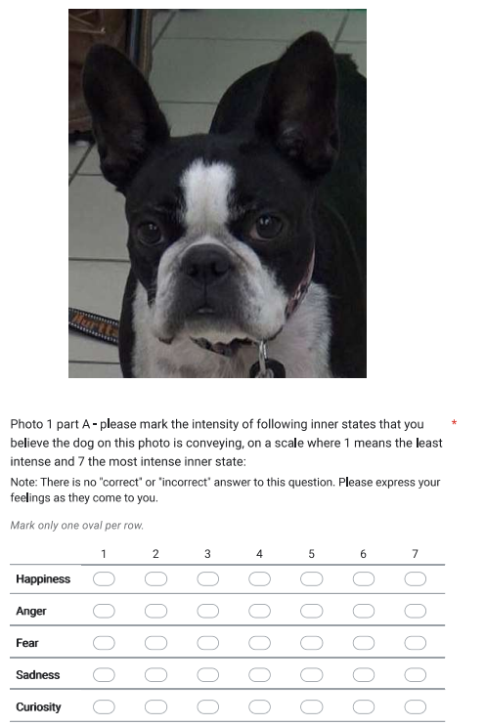



**Fig. 5:** Dog's image in Google Forms.

**Fig. 6:** First question in the Google Forms.

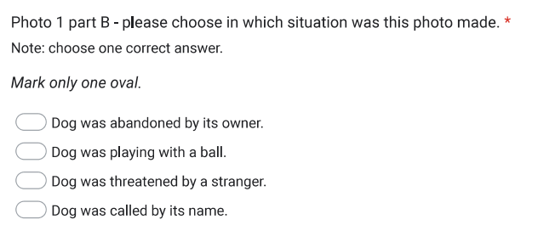

**Fig. 7:** Second question in the Google Forms.

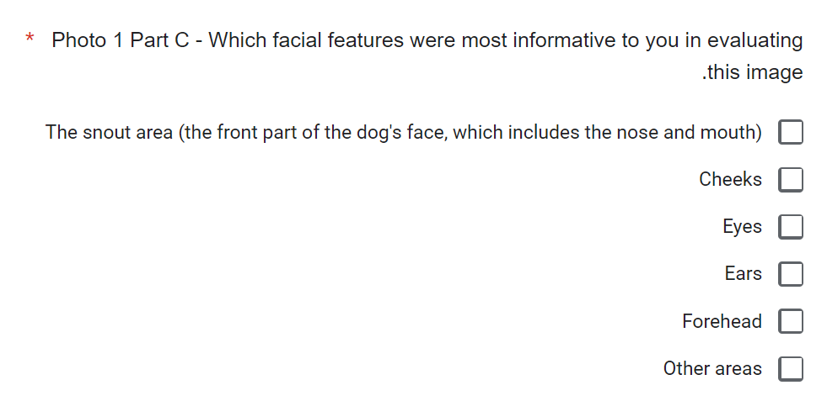

**Fig. 8:** Third question in the Google Forms.

The study was approved by the Research Ethics Committee of Braude Academic College of Engineering (Approval number 2042-05).

# 5. Results

The current research focused on analyzing differences in emotional and behavioral observation between brachycephalic dogs and normocephalic dogs by tracking the eye movements of participants who evaluated images of dogs from both types. Participants were asked about their perceptions and emotional responses to each of the dogs, and the collected data was analyzed to understand the recurring patterns in the areas where the participants were looking. Additionally, a comparison was made between the number of visits to different areas on the dogs' faces and the intensity of the emotional responses reported and other comparisons. The findings presented below are based on a summary of the eye-tracking data from the software and the responses to the questionnaire received from the participants.

## 5.1. The average number of visits to the images

## In this section, we analyze the average number of visits to the images of brachycephalic dogs versus images of normocephalicdogs. We start by some detailed description of the data.

**A brief description of the data:** In the experiment, 45 participants viewed images of brachycephalic dogs (short-nosed) and normal (normocephalic) dogs. The purpose of the measurement was to examine the number of visits - the times each participant focused on images of dogs from both breeds.

**Table 1.** **Number of visits to images of brachycephalic and normocephalic dogs.**

|  |  |  |
| --- | --- | --- |
| **Number of Visits of brachycephalic dog's images** | **Number of Visits normocephalic dog's images** | **Participant** |
| 44 | 32 | 1 |
| 69 | 51 | 2 |
| 143 | 90 | 3 |
| 68 | 81 | 4 |
| 80 | 109 | 5 |
| 78 | 54 | 6 |
| 53 | 59 | 7 |
| 91 | 64 | 8 |
| 47 | 43 | 9 |
| 124 | 111 | 10 |
| 99 | 50 | 11 |
| 125 | 121 | 12 |
| 104 | 66 | 13 |
| 105 | 75 | 14 |
| 104 | 81 | 15 |
| 47 | 40 | 16 |
| 123 | 77 | 17 |
| 65 | 59 | 18 |
| 121 | 115 | 19 |
| 65 | 48 | 20 |
| 126 | 46 | 21 |
| 137 | 68 | 22 |
| 93 | 69 | 23 |
| 91 | 139 | 24 |
| 100 | 63 | 25 |
| 83 | 68 | 26 |
| 124 | 51 | 27 |
| 138 | 49 | 28 |
| 71 | 33 | 29 |
| 24 | 16 | 30 |
| 136 | 131 | 31 |
| 140 | 130 | 32 |
| 118 | 40 | 33 |
| 200 | 128 | 34 |
| 171 | 79 | 35 |
| 124 | 86 | 36 |
| 117 | 59 | 37 |
| 98 | 38 | 38 |
| 173 | 148 | 39 |
| 115 | 104 | 40 |
| 71 | 53 | 41 |
| 95 | 102 | 42 |
| 116 | 95 | 43 |
| 105 | 106 | 44 |
| 95 | 85 | 45 |
| 102.5777778 | 75.82222222 | **Average** |
| **36.02365945** | **32.38075248** | **STDEV** |

Each number in the columns representing the number of visits for each participant results from the sum of all visits for all areas together for images of normocephalic or brachycephalic dogs. That is, for each participant, all visits to all images of normocephalicdogs were summed up, and the total number was recorded in a table. A similar process was performed for the brachycephalic dog images. This process is done for each participant.

**1. Comparing the averages:**

* The average number of visits for images of brachycephalic dogs was 102.58 seconds.
* The average number of visits for images of normocephalicdogs was 75.82.

**2. The result analysis:**

* + The results indicate that the number of visits to images of brachycephalic dogs is on average about 35% higher than to images of normocephalicdogs.
  + This result means that participants spent more time on images of brachycephalic dogs, which could indicate an increased interest or difficulty in recognizing their expressions compared to normocephalic dogs.

**Visual graph of the results:**

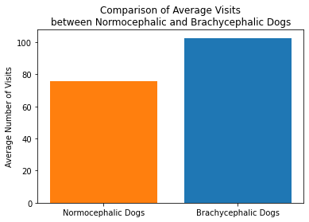

**Fig. 9:** Comparison of Average visits between normocephalic and brachycephalic dogs' images.

**Summary:** These results indicate that participants tended to pay more attention to brachycephalic dogs than to normocephalic dogs, possibly due to greater interest or greater difficulty in recognizing their expressions.

## 5.2. The average amount of time spent looking at images

This section focuses on the average amount of time in milliseconds that each of the participants spent looking at the images of both dog types.

**Table 2. Time duration of looking at images of brachycephalic and normocephalic dogs.**

|  |  |  |
| --- | --- | --- |
| **Time duration -brachycephalic dog's images** (milliseconds) | **Time duration -normocephalic dog's images** (milliseconds) | **Participant** |
| 42897 | 24213 | 1 |
| 35805 | 21604 | 2 |
| 90533 | 66110 | 3 |
| 57868 | 65361 | 4 |
| 87246 | 144945 | 5 |
| 54363 | 36943 | 6 |
| 48560 | 62575 | 7 |
| 58624 | 44250 | 8 |
| 30685 | 25847 | 9 |
| 71294 | 62265 | 10 |
| 81954 | 32913 | 11 |
| 78626 | 70951 | 12 |
| 81290 | 34872 | 13 |
| 49023 | 32045 | 14 |
| 73941 | 49264 | 15 |
| 32342 | 18411 | 16 |
| 75268 | 35835 | 17 |
| 48170 | 47974 | 18 |
| 98479 | 95636 | 19 |
| 35737 | 25878 | 20 |
| 60196 | 18232 | 21 |
| 86710 | 45637 | 22 |
| 60956 | 47272 | 23 |
| 51256 | 69971 | 24 |
| 83729 | 53966 | 25 |
| 78427 | 47978 | 26 |
| 65518 | 25769 | 27 |
| 75841 | 30962 | 28 |
| 68636 | 24874 | 29 |
| 31867 | 23460 | 30 |
| 77222 | 85787 | 31 |
| 107856 | 95209 | 32 |
| 58976 | 22636 | 33 |
| 122676 | 73539 | 34 |
| 94050 | 52091 | 35 |
| 80545 | 52033 | 36 |
| 60211 | 31386 | 37 |
| 57122 | 21754 | 38 |
| 115804 | 104495 | 39 |
| 87173 | 69278 | 40 |
| 52374 | 37436 | 41 |
| 60256 | 52582 | 42 |
| 65083 | 57538 | 43 |
| 67657 | 55224 | 44 |
| 56711 | 40928 | 45 |
| **67990.15556** | **49731.75556** | **Average** |
| **21633.71893** | **26291.87705** | **STDEV** |

Each number in the columns representing the amount of time spent viewing images of normocephalicor brachycephalic dogs for each participant is derived from the sum of viewing times across all images. That is, for each participant, all the periods of time he spent looking at images of normocephalicdogs were summed up, and the total number was recorded in a table. A similar process was carried out for images of brachycephalic dogs.

1. **Comparing the averages:**

* The average duration for images of brachycephalic dogs was 67,990.16 milliseconds.
* The average duration for images of normocephalicdogs was 49,731.76 milliseconds.

1. **The result analysis:**

The results show that the amount of time devoted to images of brachycephalic dogs was about 37% higher than to images of normocephalicdogs.

This result means that participants spent more time on images of brachycephalic dogs, which could indicate an increased interest or difficulty in recognizing their expressions compared to normocephalicdogs.

**Visual graph of the results:**

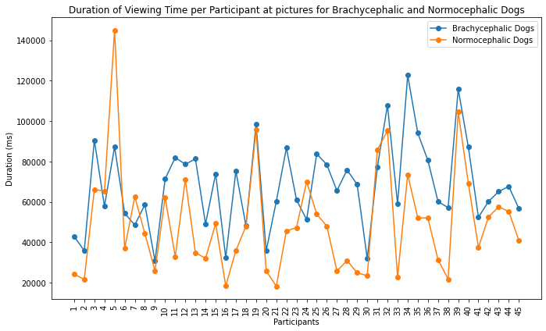

**Fig. 10:** Time duration looking at images of brachycephalic and normocephalic dogs, per participant.

**Summary:** These results indicate that participants tended to spend more time looking at images of brachycephalic dogs than normocephalicones, possibly due to greater interest or greater difficulty in recognizing their expressions.

## 5.3. The average number of visits to the AOI's

**Brief description of the data:** The experiment measured visits to specific areas in images, such as eyes, ears, cheeks, forehead, and nose, and performed surgery for each eye, ear, and cheek separately.

The areas of the dog's face shown in the following table are marked in Fig. 4.

**Table 3. Total number of visits to AOI's of brachycephalic and normocephalic dogs.**

|  |  |  |
| --- | --- | --- |
| **The total number of visits to areas of interest in images of brachycephalic dogs** | **The total number of visits to areas of interest in images of normocephalic dogs** | **AOI** |
| 131 | 52 | Cheek1 |
| 36 | 77 | Cheek2 |
| 487 | 135 | Ear1 |
| 345 | 166 | Ear2 |
| 1171 | 825 | Eye1 |
| 667 | 959 | Eye2 |
| 788 | 558 | Forehead |
| 991 | 640 | Snoutarea |
| **Average** | **Average** | **AOI** |
| 2.911111111 | 1.155555556 | Cheek1 |
| 0.8 | 1.711111111 | Cheek2 |
| 10.82222222 | 3 | Ear1 |
| 7.666666667 | 3.688888889 | Ear2 |
| 26.02222222 | 18.33333333 | Eye1 |
| 14.82222222 | 21.31111111 | Eye2 |
| 17.51111111 | 12.4 | Forehead |
| 22.02222222 | 14.22222222 | Snoutarea |
| **8.929960668** | **8.05827978** | **STDEV** |

The table displays the cumulative number of visits for a participant in various dog image areas, encompassing data from both normocephalicand brachycephalic dogs.

**Comparing averages by areas:**

* Cheeks:

right Cheek:

* The average number of visits to dogs in brachycephalic: 2.91
* Average visits for normocephalicdogs: 1.15

left Cheek:

* The average number of visits to dogs in brachycephalic: 0.8
* Average visits for normocephalicdogs: 1.71

Analysis: the right cheek of brachycephalic dogs received more attention, while the left cheek of normocephalicdogs received more attention than brachycephalic dogs. Maybe the focus was depending on the angle of the image and the tilt of the dog's head.

* Ears:

right ear:

* The average number of visits to dogs in brachycephalic: 10.82
* Average visits for normocephalicdogs: 3.00

left ear:

* The average number of visits to dogs in brachycephalic: 7.67
* Average visits for normocephalicdogs: 3.69

Analysis: The ears of the brachycephalic dogs, and especially the right ear, received much more attention (3 to 4 times) than the ears of the normocephalicdogs. The shape of the ear and its structure may be of interest or need more focus.

* Eyes:

right eye:

* The average number of visits to dogs in brachycephalic: 26.02
* Average visits for normocephalicdogs: 18.33

left eye:

* The average number of visits to dogs in brachycephalic: 14.82
* Average visits for normocephalicdogs: 21.31

Analysis: the right eye of brachycephalic dogs received more attention (about 42% more than normocephalicdogs), while the left eye of normocephalicdogs received more attention than brachycephalic dogs. It is possible that the special facial structure of brachycephalic dogs requires more focus on the right eye, or the focus was depending on the angle of the image and the tilt of the dog's head.

* Forehead:
* The average number of visits to dogs in brachycephalic: 17.51
* Average visits for normocephalicdogs: 12.40

Analysis: The forehead of brachycephalic dogs attracted more attention (about 41% more), indicating its importance as a focal point during observation of their facial structure.

* Snout area:
* The average number of visits to dogs in brachycephalic: 22.02
* Average visits for normocephalicdogs: 14.22

Analysis: the short snout of the brachycephalic dogs attracted much more attention (about 55% more). The short muzzle structure may arouse more interest or need for participants' focus to understand the dog's expressions.

**Visual graph of the results:**

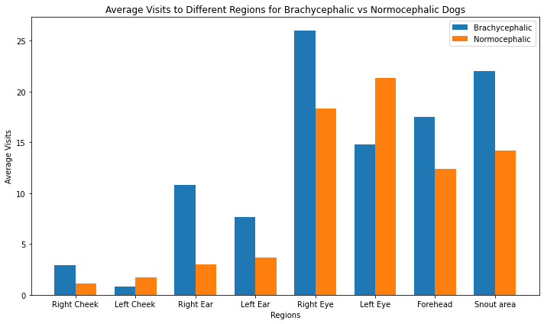

**Fig. 11:** Comparison of Average visits between normocephalic and brachycephalic dogs' AOI's.

**Summary:** Participants primarily focused on dogs in the brachycephalic, particularly in eyes, snout area, and forehead. On normocephalic dogs, they focused particularly on eyes. In almost all areas of interest, participants focused more visits on brachycephalic dogs, suggesting their unique appearance necessitates more visits attention for understanding their facial expressions.

## 5.4. The average amount of time spent looking at AOI's

**A brief description of the data**: participants focused on specific areas in images, such as eyes, ears, cheeks, forehead, and nose area, and surgery was performed for each eye, ear, and cheek separately.

This section focuses on the average amount of time in milliseconds that each of the participants spent looking at the areas of interest of both dog types.

**Table 4. Time duration of looking at AOI's** **of brachycephalic and normocephalic dogs.**

|  |  |  |
| --- | --- | --- |
| **AOI** | **The total time of visits to AOI's in images of normocephalic dogs** | **The total time of visits to AOI's in images of brachycephalic dogs** |
| Cheek1 | 19720 | 52988 |
| Cheek2 | 32185 | 13828 |
| Ear1 | 52640 | 201664 |
| Ear2 | 65750 | 156154 |
| Eye1 | 322695 | 495931 |
| Eye2 | 407926 | 274213 |
| Forehead | 197377 | 306349 |
| Snout area | 311285 | 505104 |
| **AOI** | **Average** | **Average** |
| Cheek1 | 438.2222 | 1177.511 |
| Cheek2 | 715.2222 | 307.2889 |
| Ear1 | 1169.778 | 4481.422 |
| Ear2 | 1461.111 | 3470.089 |
| Eye1 | 7171 | 11020.69 |
| Eye2 | 9065.022 | 6093.622 |
| Forehead | 4386.156 | 6807.756 |
| Snout area | 6917.444 | 11224.53 |
| **STDEV** | **3427.729** | **4072.111** |

The table shows the cumulative time participants spent on different dog image areas of interest, comparing normocephalicand brachycephalic dogs.

1. **Comparing averages by areas:**

* Cheeks:
* Average time to right cheek of brachycephalic dogs: 1177.511ms
* Average time to right cheek of normocephalicdogs: 438.2222ms
* Average time to left cheek of brachycephalic dogs: 307.2889ms
* Average time to left cheek of normocephalicdogs: 715.2222ms

Analysis: Participants spent about 63% more time on the right cheeks of brachycephalic dogs compared to normocephalicdogs. However, the left cheek of normocephalicdogs received about 57% more focus time than the left cheek of brachycephalic dogs. It's possible that the focus was depending on the angle of the image and the tilt of the dog's head.

* Ears:
* Average time to right ear of brachycephalic dogs: 4481.422ms
* Average time to right ear of normocephalicdogs: 1169.778ms
* Average time to left ear of brachycephalic dogs: 3470.089ms
* Average time to left ear of normocephalicdogs: 1461.111ms

Analysis: participants spent approximately 74% more time on the right ear of brachycephalic dogs compared to normocephalicdogs. In the left ear, participants spent about 58% more time on brachycephalic dogs than on normocephalic dogs. It is possible that the shape and size of the ear's changes according to the angle of the dog's head, so the participants will spend more time on the most informative ear.

* Eyes:
* Average time to right eye of brachycephalic dogs: 11020.69ms
* Average time to right eye of normocephalicdogs: 7171ms
* Average time to left eye of brachycephalic dogs: 6093.622ms
* Average time to left eye of normocephalicdogs: 9065.022ms

Analysis: The right eye of brachycephalic dogs received about 53% more viewing time compared to normocephalicdogs. However, the left eye of normocephalicdogs received about 49% more viewing time than brachycephalic and this may be because the way the images were presented, or the arrangement of the experiment may have affected the participants' scanning patterns

* Forehead:
* The average time to forehead for brachycephalic dogs: 6807.756ms
* Average time to forehead for normocephalicdogs: 4386.156ms

Analysis: The forehead of brachycephalic dogs took about 55% more viewing time compared to normocephalicdogs. Many brachycephalic dogs are characterized by wrinkles and excess skin in the forehead area, creating a more complex appearance that requires a longer time to visually process.

* Snout area:
* The average time to snout area for brachycephalic dogs: 11224.53ms
* Average time to snout area for normocephalicdogs: 6917.444ms

Analysis: The short and flat snout of brachycephalic dogs took about 62% more viewing time than normocephalicdogs. The unique snout structure of the brachycephalic may be a reason why the participants paid more attention to it, probably to understand their facial expressions or behavior.

**Visual graph** **of the results:** 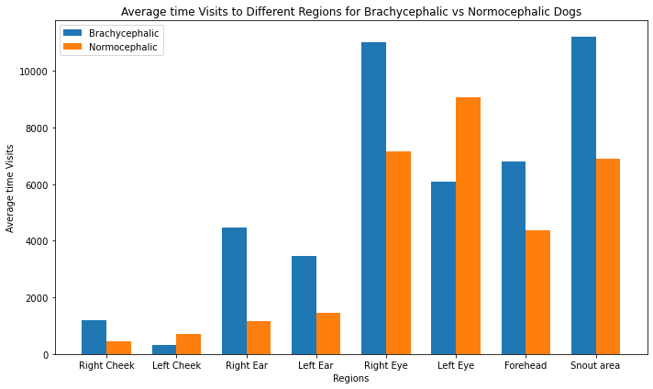

**Fig. 12:** Comparison of Average time visits between normocephalic and brachycephalic dogs' AOI's.

**Summary:** The findings indicate that brachycephalic dogs attracted more focus time from the participants in most areas tested. It is possible that the unique structure of their faces requires more focus to understand their expressions, probably the flat snout and prominent eyes of brachycephalic dogs create a unique appearance that may draw more attention to the right eye.

# 5.5. Comparing perception and viewing

In this section we compare participant reports versus eye tracking results.

1. **Analysis of the questionnaire graphs according to dog types:**

|  |
| --- |
| Snout area |
| Cheeks |
| Eyes |
| Ears |
| Forehead |
| Other features |

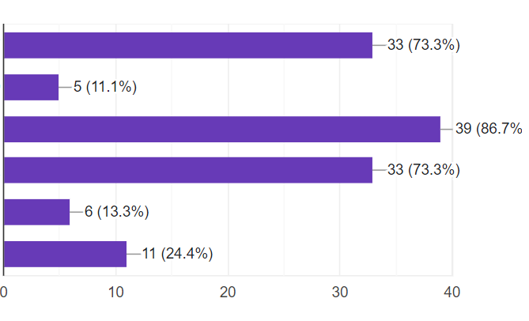

**Fig. 13:** Questionnaire brachycephalic dog's graph.

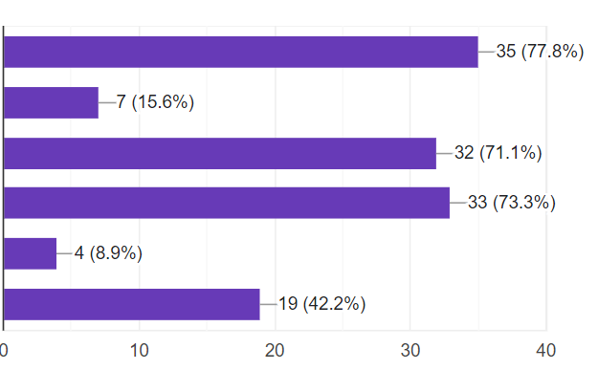

|  |
| --- |
| Snout area |
| Cheeks |
| Eyes |
| Ears |
| Forehead |
| Other features |

**Fig. 14:** Questionnaire normocephalic dog's graph.

The first graph shows the results of the answers to the question about which facial parts in dogs with short noses (brachycephalic dogs) the participants thought were the most informative.

The second graph shows the same results but for normal (normocephalic) dogs.

**Brachycephalic dogs:**

* The participants significantly indicated that the most informative area was the eyes (86.7%).
* Ears and snout area (73.3%).
* The dog's cheeks, forehead and other features received less attention.

**Normocephalic dogs:**

* On normocephalic dogs, the snout area received the most attention (77.8%).
* The ears received (73.3%), the eyes received (71.1%).
* The forehead (8.9%) and cheeks (15.6%) received less attention compared to the other areas.

**Table 5. Comparison of the results from the software (Tobii Pro Lab) for the number of visits by areas of interest.**

|  |  |  |
| --- | --- | --- |
| **The average number of visits to areas of interest in images of brachycephalic dogs** | **The average number of visits to areas of interest in images of normocephalic dogs** | **AOI** |
| 2.911111111 | 1.155555556 | Cheek1 |
| 0.8 | 1.711111111 | Cheek2 |
| 10.82222222 | 3 | Ear1 |
| 7.666666667 | 3.688888889 | Ear2 |
| 26.02222222 | 18.33333333 | Eye1 |
| 14.82222222 | 21.31111111 | Eye2 |
| 17.51111111 | 12.4 | Forehead |
| 22.02222222 | 14.22222222 | Snoutarea |
| **8.929960668** | **8.05827978** | **STDEV** |

This table produced from the software shows the average visits (the number of times the participants looked at different areas) according to the types of dogs.

**Brachycephalic dogs:**

* The average visits show that the area that received the most visits is the eye area (26.02 visits to the right eye, 14.8 visits to the left eye).
* Snout area (22.02 Visits), and forehead (17.51 ​​Visits) also received significant visits.
* The cheek area received relatively fewer visits (Cheek1: 2.91 visits).

**Normocephalic dogs:**

* The left eye received the most attention here as well (Eye2: 21.31 visits), the right eye received 18.33.
* The snout area (14.22 Visits) received a fairly high ratio.
* The forehead, ears and cheeks received fewer visits compared to the other areas.

1. **Comparative analysis:**

Is there a match between what the participants reported as informative information and where their attention was actually focused. Here are some insights on the comparison:

**Cheek area:**

* Questionnaire:
* Brachycephalic: 11.1%
* Normocephalic: 15.6%
* Tobii software:
* Brachycephalic: 2.91 visits on average
* Normocephalic: 1.71 visits on average

**Conclusion**: The participants did not identify the cheek area as informative in the questionnaire, and the data from the software also indicate a small number of visits to this area. Therefore, there is a match between their reporting and actual performance.

**Eye area:**

* Questionnaire:
* Brachycephalic: 86.7%
* Normocephalic: 71.1%
* Tobii software:
* Brachycephalic: 26.02 visits on average
* Normocephalic: 21.31 visits on average

**Conclusion**: In both races, the participants reported that the eyes are a very informative area, and the software also shows a high number of visits to the eye area. That is, there is a strong match between the report and the actual performance.

**Ear area:**

* Questionnaire:
* Brachycephalic: 73.3%
* Normocephalic: 73.3%
* Tobii software:
* Brachycephalic: 7.67 visits on average
* Normocephalic: 10.82 visits on average

**Conclusion**: despite the high reporting in the questionnaire about the ears as an informative area, the software shows that the number of visits to the ears is much lower, especially in brachycephalic dogs. Here there is a certain discrepancy between the report of the participants and the actual behavior.

**Forehead area:**

* Questionnaire:
* Brachycephalic: 13.3%
* Normocephalic: 8.9%
* Tobii software:
* Brachycephalic: 17.51 ​​visits on average
* Normocephalic: 12.4 visits on average

**Conclusion**: there is a discrepancy in the forehead area. In the questionnaire, participants reported the forehead as a less informative area, but the software observed a greater number of actual visits to this area.

**Snout area:**

* Questionnaire:
* Brachycephalic: 73.3%
* Normocephalic: 77.8%
* Tobii software:
* Brachycephalic: 22.02 visits on average
* Normocephalic: 14.22 visits on average

**Conclusion**: In the questionnaire, the participants reported the nose area as informative, but the data from the software show a less significant number of visits. This indicates a discrepancy between their reporting and what they actually focused on.

**Visual graphs of the results:**

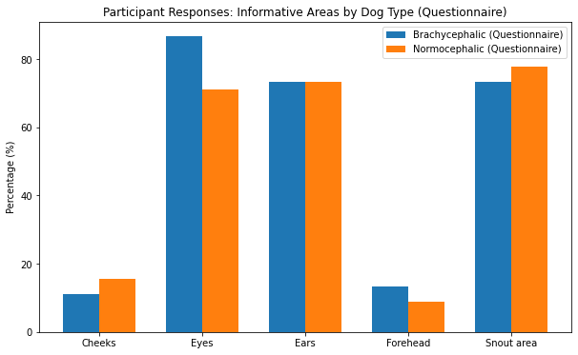

**Fig. 15:** Participants responses from Google Forms.

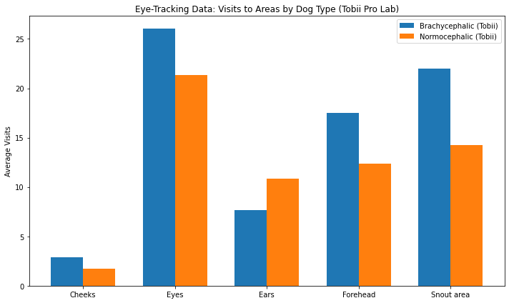

**Fig. 16:** Eye-Tracking data results from Tobii Pro Lab software.

**General conclusions:**

* The eye area is the best example of the correspondence between reporting and actual use: participants reported that it was the most informative area, and the software confirmed this with a high number of visits.
* The ears and snout area indicate a gap: while participants reported them as very informative, the software showed lower visits.
* The forehead area was less informative according to the questionnaire, but received more visits to the software, especially in brachycephalic dogs.

In general, it can be seen that in some areas there is a match between the reports in the answers to the questionnaire and the findings from the software, but in other areas there is a significant gap which can indicate a certain difficulty for the participants to assess exactly what they focused on during the viewing. There are several possible reasons why participants did not accurately report their areas of focus:

**Limited awareness:** Participants may not be fully aware of their eye movements, especially when looking at images naturally.

**Memory biases:** After viewing, participants may remember mostly the areas they think were most important, and not necessarily the ones they looked at the longest.

**Influence of social expectations:** Participants may report focusing on areas they think they are "supposed" to look at, instead of their actual areas of focus.

**Speed ​​of eye movements:** Eye movements are very fast, and participants may not be able to consciously track them.

**Differences in time perception:** Participants may inaccurately estimate the amount of time they spent in different areas.

**Influence of emotions:** Areas that evoked a strong emotional response may be perceived as areas that were viewed longer, even if this was not the case.

**The complexity of the stimulus:** complex or dynamic images may make it difficult for participants to accurately remember their viewing patterns.

These gaps highlight the need to combine objective measurement methods such as eye movement tracking with subjective reports to provide a comprehensive understanding of participants' viewing behavior.

## 5.6 Analysis of the Dog's Presented Situation

**Table 6. Participant Responses to Emotional Situations Depicted in Brachycephalic and Normocephalic Dog image.**

|  |  |  |  |  |  |  |
| --- | --- | --- | --- | --- | --- | --- |
| Comments on match/mismatch | Called by name | Stranger | Separation | Play | Correct Answer | Image |
| Mismatch | 12 | 12 | 21 | 0 | Called by name | Image1 (Brachycephalic dog) |
| Mismatch | 31 | 10 | 3 | 1 | Stranger | Image2 (Brachycephalic dog) |
| Mismatch | 12 | 1 | 2 | 30 | Called by name | Image3 (Normocephalic dog) |
| Mismatch | 14 | 14 | 16 | 1 | Play | Image4 (Brachycephalic dog) |
| Match | 1 | 15 | 28 | 1 | Separation | Image5 (Normocephalic dog) |
| Mismatch | 11 | 11 | 22 | 1 | Stranger | Image6 (Normocephalic dog) |
| Mismatch | 23 | 11 | 9 | 2 | Separation | Image7 (Brachycephalic dog) |
| Match | 7 | 8 | 0 | 30 | Play | Image8 (Normocephalic dog) |

In this table for each image, I checked how many people answered in each of the options. After that, we compared the correct answer for each image with the majority decision of the participants and checked whether there was a match or not.

* If the majority answered correctly for normocephalicdogs: this may indicate that it is easier to recognize and understand these dogs.
* If there is more confusion for brachycephalic dogs: this could indicate a general difficulty in recognizing emotions and situations in these dogs, probably because of the physical structure or the way they are perceived visually.
* **Analysis according to the data from the table:**
* Image 1 (Brachycephalic dog):

The vast majority (21 out of 45) were wrong and assumed that the dog was separated by its owner. This is an image of a brachycephalic dog, which probably caused the participants to perceive the dog in a vulnerable or anxious state.

* Image 2 (Brachycephalic dog):

Most of the participants (31) were wrong and thought that the dog was called by name, while the correct answer (that the dog was threatened) was given by only 10 participants.

* Image 3 (Normocephalic dog):

The vast majority (30 out of 45) were wrong and assumed that the dog was playing ball. This is an image of a brachycephalic dog, which probably caused the participants to perceive the dog in a vulnerable or anxious state.

* Image 4 (Brachycephalic dog):

Only one participant correctly identified that the dog played with the ball. The other participants were wrong and divided their answers between the other situations, especially the dog was abandoned by its owner and was threatened.

* Image 5 (Normocephalic dog):

The large majority correctly identified the situation where the dog was abandoned by its owner (28), which suggests that the participants were able to correctly identify the correct emotion in a normocephalicdog in this situation.

* Image 6 (Normocephalic dog):

There is a scattering of answers here, when a correct answer was given by only 11 participants. Most mistakenly thought that the dog had been abandoned by its owner.

* Image 7 (Brachycephalic dog):

The majority were wrong here and thought that the dog is called by his name, while only 9 participants assumed the correct answer.

* Image 8 (Normocephalic dog):

The absolute majority (30) correctly identified that the dog was playing ball, which shows the ease of identifying the emotion in normocephalicdogs in this situation.

**Table 7. Calculating the number of participants correct answers in both types.** (Numbers in red for brachycephalic images. Numbers in blue for normocephalic images.)

|  |  |  |  |  |  |  |
| --- | --- | --- | --- | --- | --- | --- |
| Comments on match/mismatch | Called by name | Stranger | Separation | Play | Correct Answer | Image |
| Mismatch | 12 | 12 | 21 | 0 | Called by name | Image1 (Brachycephalic dog) |
| Mismatch | 31 | 10 | 3 | 1 | Stranger | Image2 (Brachycephalic dog) |
| Mismatch | 12 | 1 | 2 | 30 | Called by name | Image3 (Normocephalic dog) |
| Mismatch | 14 | 14 | 16 | 1 | Play | Image4 (Brachycephalic dog) |
| Match | 1 | 15 | 28 | 1 | Separation | Image5 (Normocephalic dog) |
| Mismatch | 11 | 11 | 22 | 1 | Stranger | Image6 (Normocephalic dog) |
| Mismatch | 23 | 11 | 9 | 2 | Separation | Image7 (Brachycephalic dog) |
| Match | 7 | 8 | 0 | 30 | Play | Image8 (Normocephalic dog) |

Brachycephalic dog's images:

12+10+1+9=32 correct answers in brachycephalic dog's images.

Normocephalic dog's images:

12+28+11+30=81 correct answers in normocephalic dog's images.

32+81=113 correct answers for both types

Calculation of the percentage of correct answers for both types out of all the correct answers:

$$\frac{32}{113}*100=28.31$$

$$\frac{81}{113}*100=71.68$$

**Visual graph of the results:**

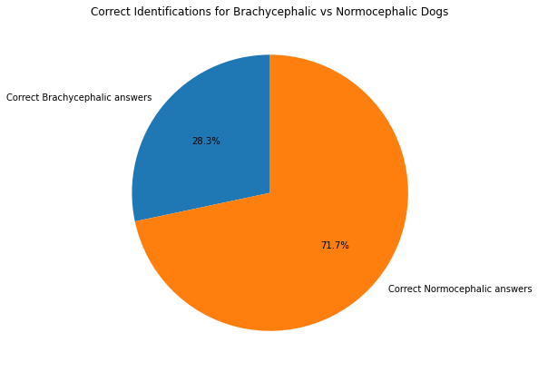

**Fig. 17:** The percentage of the correct answers for each type out of all correct answers.

**Summary:**

* There is a significant tendency for participants to correctly identify the situations in the image images of normocephalicdogs more than brachycephalic dogs.
* In the brachycephalic images, participants tended to confuse the situations and had difficulty identifying correct emotions.
* It is possible that the brachycephalic face shape creates a false impression of emotion in the dog, causing people to misinterpret the image.

## תרשים תשובות לטופס. כותרת שאלה: 1. תמונה 1 חלק א&apos; - עליך לסמן את עוצמת המצבים הרגשיים הפנימיים הבאים שאתה מאמין שהכלב בתמונה זו משדר. הערה: אין תשובה "נכונה" או "לא נכונה" לשאלה זו.. מספר תשובות: .Emotional Evaluations of Brachycephalic and Normocephalic Dogs

**Fig. 18:** Participant ratings of emotional responses to different dog images (Happiness, Anger, Fear, Sadness, Curiosity).

The study examines participants' perceptions of dogs' emotions. This graph was generated from responses to one of the questions in our Google Forms survey. Participants rated the intensity of the dog's emotional state, as perceived from a specific photo, on a scale from 1 to 7. Each number on the scale is represented by a distinct color, with each color corresponding to a specific intensity level. This approach allows us to assess how individuals interpret and evaluate the emotions conveyed through the dog's facial expressions and body language, using both a numerical and visual scale.

**Weighted average calculation:**

* We calculated the weights: for each emotion, the weights are 1 to 7 (on scale from 1 to 7).
* We multiplied the number of participants answers in each scale number by its weight.
* We calculated the sum of the multiplications.
* We divided the result by the total number of participants.

Calculation example:

Let's take the happiness for image 1 (brachycephalic dog):

* Ratings (number of answers in each scale from the 7 scales): [22, 13, 5, 4, 0, 1, 0]
* Weights: [1, 2, 3, 4, 5, 6, 7]
* Weighted calculation:

(22×1)+(13×2)+(5×3)+(4×4)+(0×5)+(1×6)+(0×7) = 85 => $\frac{85}{45}=1.888=1.89$

We will do exactly the same way for all the emotions in all the images and then we will get the weighted average ratings for the emotion of happiness for the two types of dogs:

**Happiness**

* **Brachycephalic dogs:**

• Image 1: 1.89

• Image 2: 2.76

• Image 4: 2.07

• Image 7: 2.02

* **Normocephalic dogs:**

• image image 3: 6.00

• Image 5: 1.56

• Image 6: 1.98

• Image 8: 5.42

**Anger:**

* **Brachycephalic dogs:**

• Image 1: 3.89

• Image 2: 1.89

• Image 4: 2.89

• Image 7: 1.56

* **Normocephalic dogs:**

• Image 3: 1.11

• Image 5: 2.89

• Image 6: 1.78

• Image 8: 1.67

**Fear:**

* **Brachycephalic dogs:**

• Image 1: 3.51

• Image 2: 3.33

• Image 4: 4.27

• Image 7: 3.56

* **Normocephalic dogs:**

• Image 3: 1.16

• Image 5: 4.00

• Image 6: 4.44

• Image 8: 1.69

**Sadness:**

* **Brachycephalic dogs:**

• Image 1: 4.82

• Image 2: 2.89

• Image 4: 4.33

• Image 7: 4.31

* **Normocephalic dogs:**

• Image 3: 1.33

• Image 5: 5.44

• Image 6: 5.64

• Image 8: 1.49

**Curiosity:**

* **Brachycephalic dogs:**

• Image 1: 3.56

• Image 2: 5.00

• Image 4: 4.33

• Image 7: 5.36

* **Normocephalic dogs:**

• Image 3: 4.67

• Image 5: 2.67

• Image 6: 3.20

• Image 8: 4.91

**Summary of emotions by dog ​​group:**

* **brachycephalic dogs:**

**Happiness:** on average, the participants tended to rate the happiness of the brachycephalic dogs at a relatively low level (average ranging from 1.89 to 2.76). This may indicate that the participants did not feel particularly strong positive feelings towards the brachycephalic dogs.This suggests that the physical appearance of brachycephalic dogs might not evoke a sense of joy or contentment among the participants.

**Anger:** Ratings for anger show a tendency towards higher levels compared to normocephalic dogs, with averages ranging from 1.56 to 3.89. This suggests that brachycephalic dogs might evoke more negative emotions such as frustration or discomfort in viewers.

**Fear:** Fear is moderately rated, with averages around 3-4, indicating that brachycephalic dogs tend to evoke some degree of anxiety or uncertainty, but not to an extreme level.

**Sadness:** High ratings for sadness (2.89 in Image 2, and around 4 for others) suggest that these dogs evoke feelings of sympathy or sorrow in participants, likely due to their appearance or perceived vulnerability.

**Curiosity:** There is a moderate to high level of curiosity, with the highest rating being 5.36 for Image 7. This suggests that brachycephalic dogs attract interest or intrigue, possibly due to their unique features.

* **Normocephalic dogs:**

**Happiness:** Ratings for happiness are significantly higher, especially in Images 3 (6.00) and 8 (5.42). This indicates that participants felt more positive emotions and perceived normocephalic dogs as happier or more content.

**Anger:** Anger ratings are lower overall compared to brachycephalic dogs, with values ranging from 1.11 to 2.89. This suggests that normocephalic dogs evoke fewer negative emotions.

**Fear:** Fear ratings are generally low, except for a spike in Image 6 (4.44). Overall, participants did not perceive normocephalic dogs as threatening or anxiety-inducing.

**Sadness:** Sadness ratings are somewhat higher in a few images, such as Image 5 (5.44) and Image 6 (5.64), but overall lower than for brachycephalic dogs, suggesting less emotional discomfort.

**Curiosity:** The curiosity ratings are moderate but not as high as for brachycephalic dogs, indicating less intrigue or unfamiliarity compared to the more exotic appearance of brachycephalic dogs.

* **General conclusion:**

**Positive Emotions:** Normocephalic dogs generally evoke more positive emotions like happiness and lower levels of anger and fear, making them more relatable and easier to interpret for participants.

**Negative Emotions:** Brachycephalic dogs tend to evoke more negative emotions, such as anger, fear, and sadness, which may be linked to their distinctive facial structure and the perception of vulnerability.

**Curiosity:** While both types evoke curiosity, brachycephalic dogs, with their unique appearance, seem to attract more interest and attention.

The findings of this study show that participants tended to attribute more negative emotions, such as fear, anger, and sadness, to brachycephalic dogs compared to normocephalic dogs, which were associated with more positive emotions like happiness. This phenomenon may be related to the unique facial features of brachycephalic dogs, characterized by a flat nose and large eyes. While one might expect these features to elicit feelings of empathy or affection, the study suggests that the flat faces of brachycephalic dogs can actually cause confusion or difficulty in interpreting their emotional expressions.

Although evolutionary changes in facial muscles may have enhanced certain expressions in brachycephalic dogs, the study indicates that these physical traits might lead people to misinterpret these dogs as being distressed. This highlights the potential gap between the physiological evolution of facial features and the human ability to accurately perceive the emotions expressed by brachycephalic dogs. It raises questions about the challenge of understanding facial expressions in dogs with such unique facial structures.

## The relationship between increasing age and the ability to identify situations in a more negative way

The ratio of positive to negative reactions is determined by dividing the number of positive reactions by the number of negative reactions, providing insight into the ratio for each age group.

**Our positive situations:** The dog played with the ball, called by his name.

**Our negative situations:** The dog was separated by its owner; the dog was threatened by a stranger.

Now we will calculate the basic ratio for each age group (over all images):

**Table 8. Age distribution and response patterns for positive and negative situations of the first image.**

|  |  |  |  |
| --- | --- | --- | --- |
| Who of them answered negative situations? | Who of them answered positive situations? | Comment number | Age |
| 6,8 | 40 | 6,8,40 | 19 |
| 34 | 44 | 34,44 | 20 |
| 16,25,4,32 | 5,22,23,42 | 4,5,16,22,23,25,32,42 | 21 |
| 18,26,28,30,37,7,20,24 | 15,31,33 | 7,15,18,20,24,26,28,30,31,33,37 | 22 |
| 3,9,29 | 17 | 3,9,17,29 | 23 |
| 1,2,39,41,14,21,35,36,38,43 | 13 | 1,2,13,14,21,35,36,38,39,41,43 | 24 |
| 11,19 |  | 11,19 | 25 |
| 12 | 27 | 12,27 | 26 |
| 45 |  | 45 | 30 |
| 10 |  | 10 | 50 |

We extracted these data for the 8 images from our personal detail's questionnaire on Google Forms.

$$ratio=\frac{The number of positive responses}{The number of negative responses}$$

For example: if an age group of 20 years has 129 positive responses (sum of the number of positive responses for age 20 from all 8 images) and 100 negative responses:

$$ratio=\frac{129}{100}=1.29$$

The positive/negative ratio indicates the proportion of positive responses to negative ones. A number greater than 1 indicates more positive responses, while a number less than 1 indicates more negative responses. A close ratio, like 1.06 or 0.91, indicates almost equal positivity/negative ratios.

After self-calculation we got:

Age 19: $ratio=\frac{11}{13}=0.846$- Negative ratio (more negative reactions than positive).

Age 20: $ratio=\frac{5}{3}=1.666$- Positive ratio (more positive reactions).

Age 21: $ratio=\frac{13}{19}=0.684$- Negative ratio

Age 22: $ratio=\frac{44}{44}=1$- Equal ratio (no advantage for one of the responses).

Age 23: $ratio=\frac{15}{17}=0.882$- Negative ratio

Age 24: $ratio=\frac{46}{42}=1.095$- Positive ratio

Age 25: $ratio=\frac{8}{8}=1$- Equal ratio

Age 26: $ratio=\frac{10}{6}=1.666$- Positive ratio

Age 30: $ratio=\frac{3}{5}=0.6$- Negative ratio

Age 50: $ratio=\frac{4}{4}=1$- Equal ratio

The data shows a certain trend where younger participants (ages 19-21) tend to have more negative responses (ratios below 1), while in certain age groups, such as 20 and 26, there is a notable increase in positive responses. In ages 22, 24, and 25, an equilibrium between positive and negative responses was observed, whereas in older age groups (30 and 50), the trend leans toward more negative or balanced responses.

The study shows no clear trend indicating age increases lead to negative responses, with age 30 showing a negative trend and age 26 showing a strongly positive response ratio, but age 50 showing equal ratio, this variation may be due to additional factors, such as our relatively small sample size in the older age groups, which could impact the statistical significance of the results.

Given the findings, it is difficult to conclude definitively that increasing age correlates with a rise in negative responses. One possible explanation is that the sample size in older age groups was small, and our study included a smaller sample of 45 participants, unlike the larger sample described in the original article of [Eretová et al., 2024], potentially affecting the reliability of the results. Additionally, factors such as personal experience with animals, cultural background, or environmental influences may have a more significant impact on responses than age alone.

**Recommendations for future research:** To confirm or disprove the hypothesis that age affects the trend of negative reactions, future research should include a larger and more diverse sample of participant age, so that the ages will be correctly distributed to help get a hypothesis and an accurate result.

## Israel VS. Prague

During our research, we focused on analyzing the participants' reactions to images of two different breeds of dogs (Boston Terrier and Jack Russell) in four emotional states: called, play, separation and threatened by a stranger. In analyzing the data, we calculated the response percentage for each state in each correct state image and compared it to data from a similar study conducted in the Czech Republic.

Main steps in the analysis process:

* **Data collection:** Participants viewed image images of the two dog breeds in the emotional states mentioned above. We got the responses of the participants from the questionnaire of each image on Google Forms.
* **Calculating the response rate:** We calculated the number of responses for each category in relation to the total of all responses (for each image) and converted this to percentages to create a stacked column graph that shows the relationships in a clear and accessible way. where each column name represents a correct state for image (so the graph of one bread has 4 columns because there are 4 images of each breed with 4 states, that’s mean one image for one state), then the column is divided into the 4 answers that the participants answered within this image.

**For example:**

First graph (Boston images):

First column – CALLED image (see Table 5):

* PLAY: 0
* SEPARATION: 21
* STRANGER: 12
* CALLED: 12

Total answers: 0+21+12+12=45

Percentage:

First column - CALLED:

* PLAY: $\frac{0}{45}*100=0\%$
* SEPARATION: $\frac{21}{45}*100=46.67\%$
* STRANGER: $\frac{12}{45}*100=26.67\%$
* CALLED: $\frac{12}{45}*100=26.67\%$

We do this for every graph and every state.

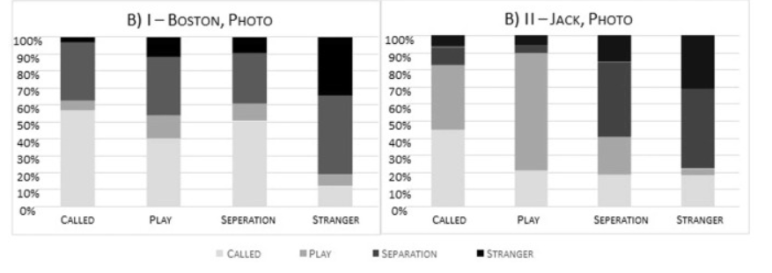

**Fig. 19:** Graphs from the original article [Eretová et al., 2024].

**Our Visual graphs of the results:**

**Fig. 20:** Answer rating for each presented situationof Boston breed.

**Fig. 21:** Answer rating for each presented situation of Jack breed.

Comparison between our graphs and the graphs from the [Eretová et al., 2024] study:

**Boston graph (image images):**

* **Called:**
* In Israel: there is a relatively balanced distribution with about 28% "called" responses, and the rest are divided between "separation" and "stranger".
* In Prague: there is a rather stronger tendency with about 56% "Called" responses, and the rest was more for "separation".
* **Play:**
* In Israel: the responses to the "Play" situation are very low, approximately less a lot than 10%, and it seems that most of the participants in Israel recognized the situation in a different way.
* In Prague: in the corresponding graph, slightly higher responses were recorded for the "Play" mode, with approximately 15% responses, with 40% for "Called".
* **Separation:**
* In Israel: the percentage of responses to the "separation" situation is relatively low, about 20%, but too high for "Called" with 50%.
* In Prague: the responses to the " separation" situation are a bit higher, with about 30% in this category.
* **Stranger:**
* In Israel: the percentage of responses to the "stranger" status is approximately 22%, There were significantly higher responses for called about 70%.
* In Prague: the percentage of responses to the "stranger" status is a bit more 30%, more responses to the " separation" condition were recorded, which shows that the participants were more likely to attribute the behavior to a "separation" than in Israel. There are about 50% separation reactions.

**Jack graph (image images):**

* **Called:**
* In Israel: there are about 30% responses to "called", relatively not so much, but there were excessive responses for play about 65%.
* In Prague: the reactions to "separation" and "stranger" are quite similar, there are about 40%-50% responses to "Called", and "play", there are about 30%-40%, which is relatively high.
* **Play:**
* In Israel: the reactions to the "play" situation stand out, especially in this breed, with about 70% of the answers indicating play. With very similar reactions of called and stranger.
* In Prague: the responses to the "play" mode stand out, especially in this breed, with almost 70% of the answers indicating play.
* **Separation:**
* In Israel: the reactions to the "separation" situation are very high, about 60%, with about 30% for "stranger", with a little of "called" and "play".
* In Prague: the reactions to the "separation" situation are a little low, about 45%, the reactions to "called" and "play" are quite similar.
* **Stranger:**
* In Israel: there are low responses to the "stranger" condition, with about 15% of the participants identifying the dog as a "stranger", with 45% for "called".
* In Prague: the percentage of responses to the "stranger" situation was higher compared to Israel by about 30%, with 50% for "separation".

**The participants in Israel:**

interpreted the positive situations as more negative and interpreted the negative situations as more positive for Boston.

But interpret the positive situations in Jack as really positive and the negative situations in Jack as really negative and this strengthens the claim about our Israelis tending to give negative situations for Boston and understand more the normocephalicdogs.

**The participants in Prague:**

Interpret the positive situations mostly as positive for both breeds specifically normocephalicdogs.

Also, the negative situations were often interpreted as negative with stronger reactions for thedogs, and here too it seems that Prague is the same and more normocephalicdogs understand.

However, the comparison between Israel and Prague points to a little difference in the perception and understanding of dog behavior. But it is important to submit that it is difficult to get really precise and absolute insights from these data. Culture differences, sample differences, and differences in testing conditions affect the results. Also, the interpretation of dog behavior may be influenced by the participants' experience and familiarity with dogs in general and with approved breeds in particular. Therefore, these insights should be considered as a general indication of response tendencies and not as an accurate and comprehensive description of dog behavior between the different populations.

# 6. Conclusion

This study highlights significant differences in how participants perceive and interpret emotions in brachycephalic and normocephalic dogs. Overall, normocephalic dogs are associated with more positive emotional responses, such as happiness, and participants found them easier to interpret. In contrast, brachycephalic dogs tend to evoke more negative emotions, including anger, fear, and sadness, potentially due to their distinctive facial features and perceived vulnerability.

The data suggests that participants spent more time and focused more attention on the facial regions of brachycephalic dogs, particularly the eyes, snout, and forehead, compared to normocephalic dogs. This increased attention may be due to the difficulty in recognizing their expressions or their unique appearance, which draws more interest. Notably, while participants reported that the eyes were the most informative area for interpreting emotions, there was a discrepancy between reported and actual focus on other areas, such as the ears and snout, indicating a gap in perceived versus actual focus.

The findings reveal that the shape and structure of a dog's face significantly influences human perception of their emotions. Brachycephalic dogs, with their flattened snouts and prominent eyes, not only attract more attention but also lead to more frequent misinterpretations of their emotional state. This misinterpretation may contribute to the more negative emotional responses they evoke, further complicating human-dog interactions.

In conclusion, this research underscores the importance of facial structure in emotional perception, suggesting that the unique appearance of brachycephalic dogs may hinder effective emotional communication and understanding. These insights have implications for dog welfare, human-animal interaction, and further research into how humans interpret non-verbal cues from different breeds.

Moreover, several hypotheses proposed in this study were supported by the results, while others were not. Notably, H3 that people would understand normocephalic dogs better than brachycephalic dogs was confirmed, aligning with the observation that normocephalic dogs were associated with more accurate emotional interpretations.

Additionally, H7 was validated, as participants spent more time examining brachycephalic dog images due to the difficulty in interpreting their expressions. H9 was also confirmed, indicating that understanding dogs is compromised due to structural distortions in brachycephalic breeds, which limit their ability to make clear facial expressions. Finally, H10 was supported, with the data demonstrating that eye-tracking technology provided more accurate insights compared to self-reported evaluations, suggesting that integrating both methods can lead to a more comprehensive understanding of emotional perception in dogs.

Conversely, H4, which predicted that participants would rate brachycephalic dogs more positively than normocephalic dogs, was not supported. In fact, brachycephalic dogs evoked more negative responses overall. Similarly, H5 the expectation that participants' ability to accurately identify situations would decrease with age was also not supported, as no significant age-related decline in emotional interpretation was observed. Finally, H6 was supported, as participants found the flat, baby-like faces of Boston Terriers, particularly their large eyes, more appealing and informative.

# 7. Challenges

**Software Updates:** Each time I opened the software on the lab computer at the college, I had to wait and update it to match the version installed on my home computer. This process was time-consuming and sometimes caused compatibility issues that could delay the project's progress.

**Shared License Usage:** The college provides a single license for Tobii Pro Lab for students, making it difficult to work simultaneously with other researchers. When someone else was using the software in the lab, I couldn't access it on my home computer, so I had to wait until they finished their work.

**Saving Projects on Different Computers:** Every change or addition I made to the project had to be saved immediately and in a designated location. If I accessed the lab computer later and hadn't saved the project correctly, all the work could be lost, necessitating extra caution during the work process.

**Self-Learning of the Software Environment:** As someone who had no prior familiarity with the software, I had to learn Tobii Pro Lab independently. I used the TOBII website to learn about the software, searched for answers to questions that arose during the work, and dealt with difficulties in understanding some of the functions and settings during the experiment's construction and data analysis.

**Technical Challenges:** In addition to the challenges mentioned, I encountered technical difficulties: such as communication with the Eye Tracker device and each participant requires individual calibration to ensure accurate data collection, and this process can be time-consuming. If the calibration fails or is inaccurate, it can lead to delays or the need to repeat the process, which disrupts the experiment’s flow.

Managing various types of stimuli (such as images, websites, and videos) within Tobii Pro Lab involves meticulous setup to ensure that each stimulus is presented correctly, and the data is accurately captured. First, each type of stimulus requires different timing and display settings to ensure consistency during participant viewing. For example, images may need to be shown for a set duration, while videos or interactive websites require precise synchronization with the participant’s eye movements across multiple frames or pages.

**Data Processing and Export:** The software generates large amounts of data, and choosing the correct format for export (e.g., AOI, fixation data) can be challenging. Sometimes, the data format required for analysis (such as Excel or CSV) might not immediately align with the analysis software, requiring manual conversion or additional processing steps.

Despite the numerous challenges and obstacles encountered during the project, the dedication and perseverance paid off, resulting in a smooth and successful completion.

# 8. User Guide

To make the experiment more accessible, we've prepared a brief user guide on how to create an experiment in the system.

**Creating a New Experiment:**

Open Tobii Pro Lab, ensure that the software is updated to the latest version, and select “Create New Project.” Choose your project type, then you need to go to "Design" to begin creating your experiment.

**Fig. 22:** The project design interface in Tobii Pro Lab.

You need to click on "eye tracking calibration" and set the "target number" in the properties on the right side. It depends on your project. The bigger the number is, the more accurate it will be.

To create and build your timeline, you need to define the experiment’s parameters, including adding stimuli (images, videos, text, group element or websites) and task instructions with properties for each stimulus (presentation settings), including name, position, advance on (how to pass from this stimulus to the next one), background color, presentation time. Use the timeline to arrange the stimuli in the desired order.

The timeline is your primary tool for organizing and sequencing stimuli. Drag and drop stimuli into the timeline and adjust their duration. Add events, such as participant responses or triggers, to track specific interactions.

Import stimulus files (e.g., images, videos) by clicking on “Add Stimuli.” For web stimuli, enter the URL directly and configure settings such as display duration and interactivity. Preview each stimulus to ensure it is displayed correctly.

**Fig. 23:** Interface for editing or adding images/video/other stimuli in Tobii Pro Lab and editing the properties over the stimuli.

Now it's the time to set up your Areas of Interest (AOIs) on each stimulus like images or videos to analyze specific regions.

In Tobii Pro Lab software, defining Areas of Interest (AOI) is done separately for each image or stimulus. Each stimulus may contain unique areas of interest according to its content, and the user can manually or automatically define the AOI for each image.

The precise definition of areas of interest depends on the research objectives and which parts of the image the researchers are interested in analyzing (such as eyes, ears, mouth, etc.). After setting the AOI, the software can analyze where participants focus their gaze, how much time they spend on each area, and what gaze patterns exist within and outside the area.

This way, data can be obtained on participant behavior for each stimulus separately, taking into account the unique definitions of areas of interest in each stimulus.

So, you need to go to "Analyze" then to "AOI tool", there you can find your stimuli, press on the one you want to add for it AOI's.



**Fig. 24:** Interface for adding AOI's to images/video/other stimuli in Tobii Pro Lab.

When you click on the stimulus you want to start drawing areas of interest in it, you'll see the word "Draw" above the stimulus. This is where you can add and outline the area of interest relevant to you. There are 3 options for drawing, one can choose the most appropriate in terms of accuracy (ensuring you can include any part of the area of interest).

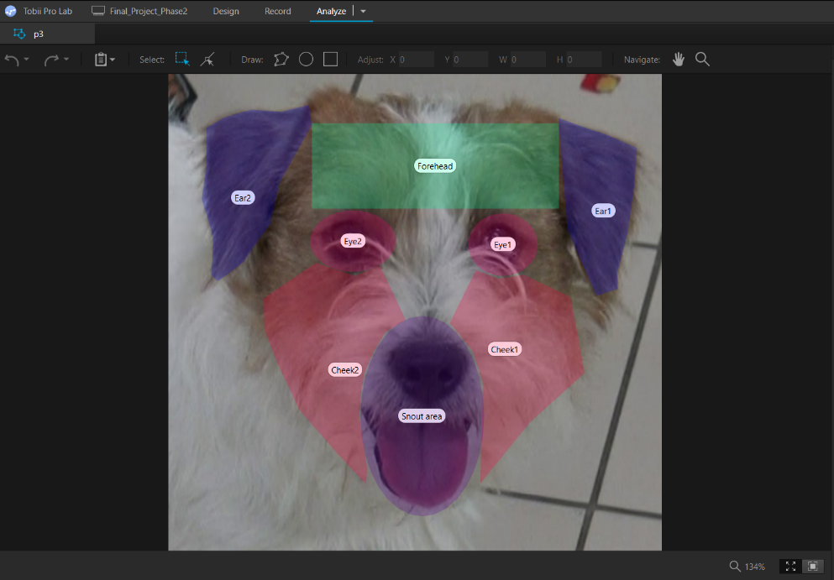

**Fig. 25:** Example of an image after drawing AOI's (e.g., a dog's face or body).

After Finishing all the AOI's drawing in your stimuli you want, now you can add the questions in Google Forms platform:

Now you need to create a questionnaire, for example in Google Forms, for each image and its accompanying questions. It's preferable to include the image again in the questionnaire because it's not possible to go back once you've moved to the next stimulus. In the software, you can define how to move from one stimulus to another, for example, from a web stimulus to the next stimulus using F10. If you have various stimuli that are dependent on each other, you can simply use "Add group element" where you add stimulus types (see Figure 23) and drag them into it. This allows you to have a more organized timeline. Within the group element, you can specify that everything inside it will proceed in order.

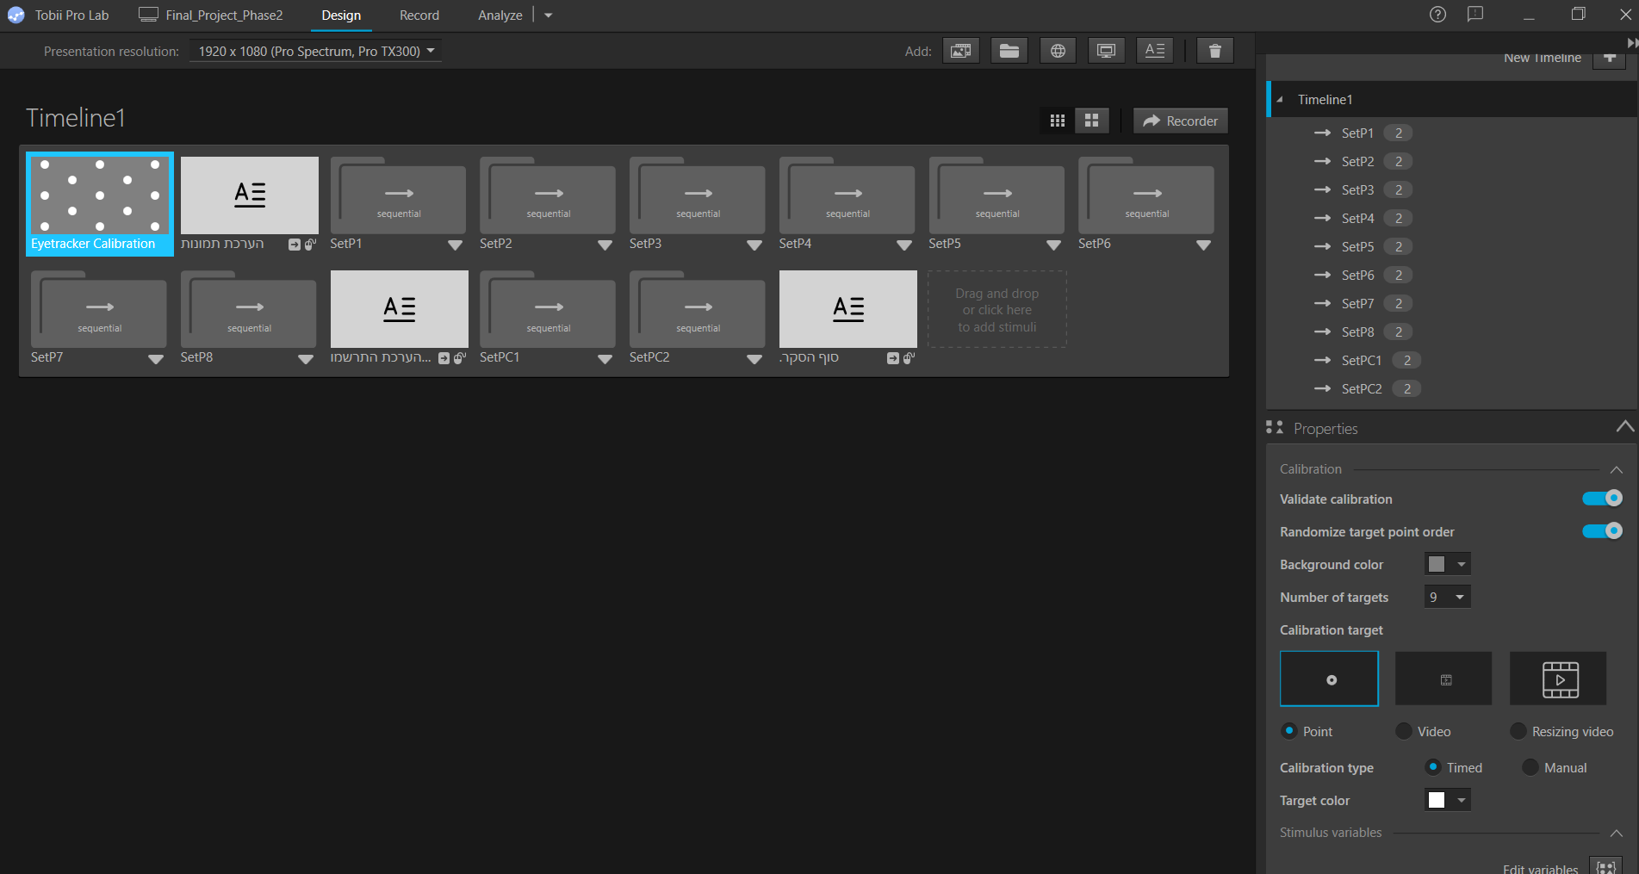

**Fig. 26:** Image for how project look after design it.

After we have built the experiment in the software and defined areas of interest (AOI) in the images or videos, it is necessary to switch to recording so that the software allows the recording of the participants in the experiment after installing the appropriate gaze tracking device. The eye tracking device, like that of Tobii Pro spark, interfaces with the software and enables accurate tracking of the eye movements of the participants while they watch pre-defined images or videos, we can connect the device on the upper left side inside "Record".

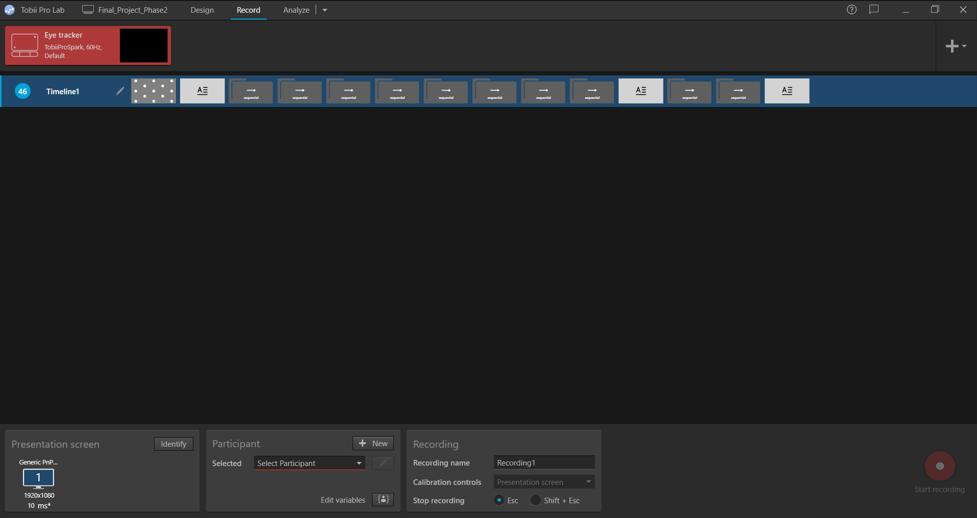



**Fig. 27:** Image for connecting the eye tracker.

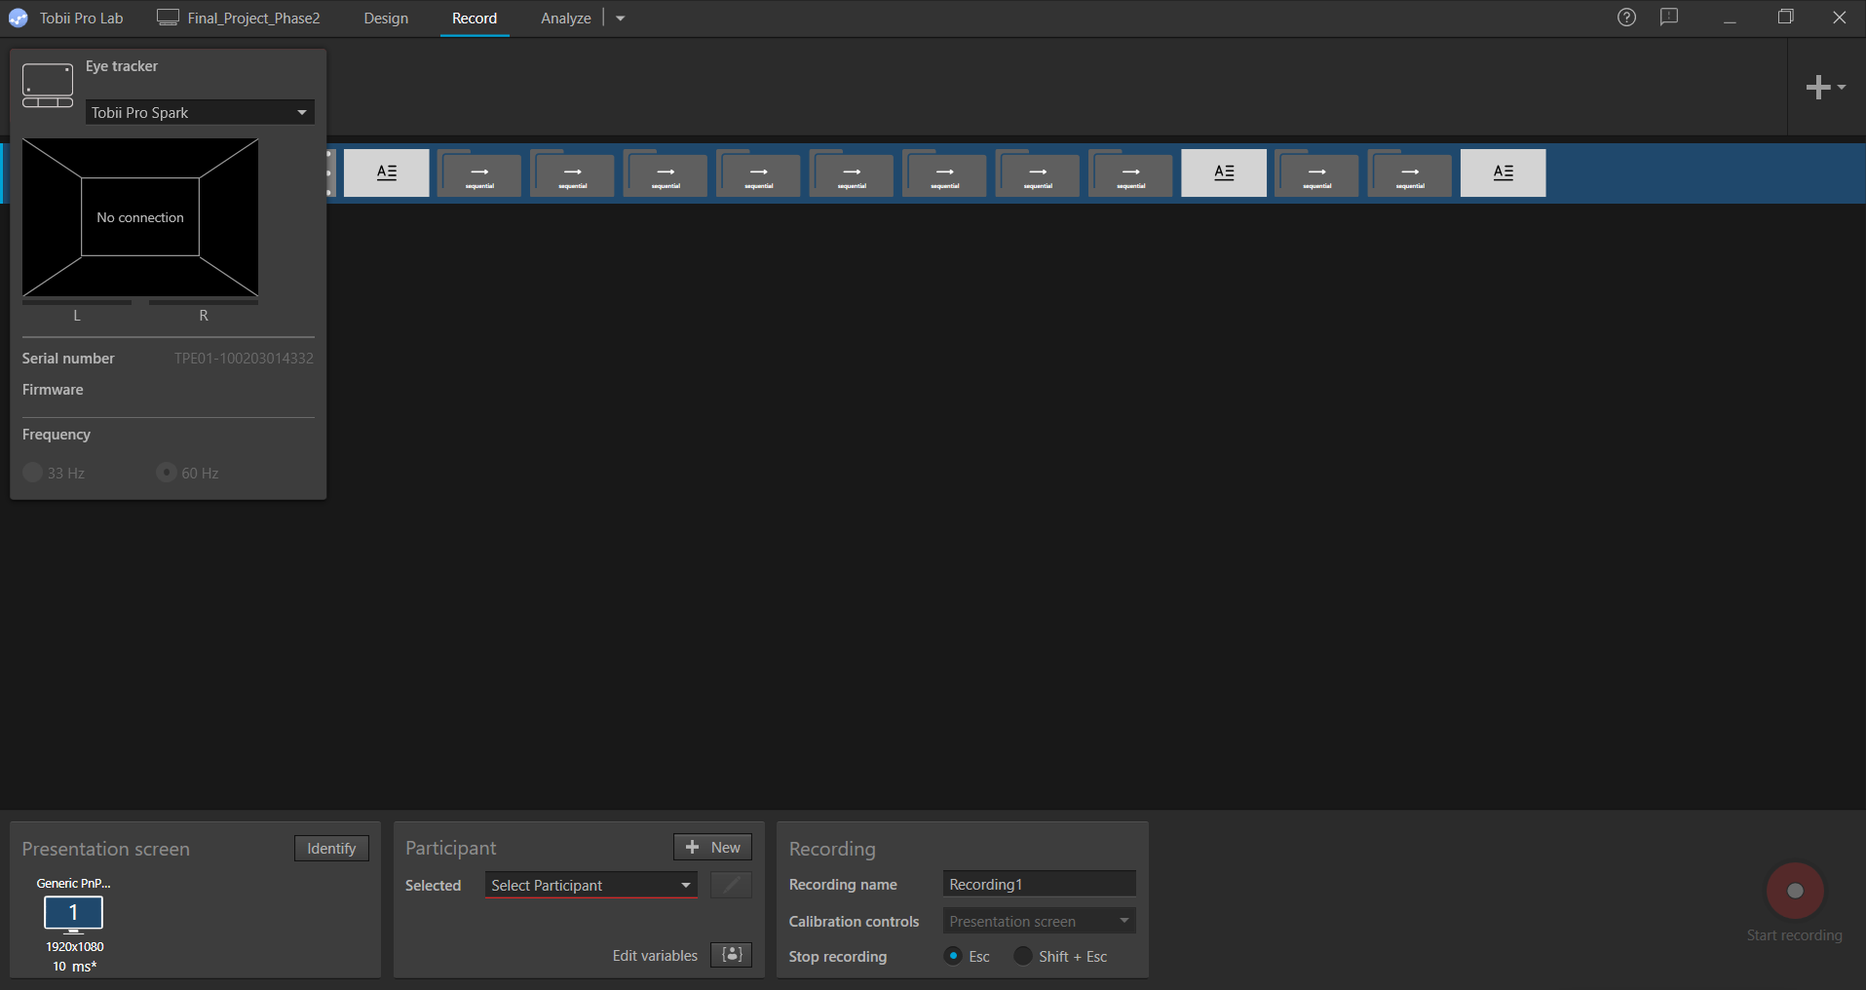



**Fig. 28:** Image for choosing the relevant eye tracker.

Then you need to input user ID in the record section, you need to give the same ID in "Participant" and "Recording" squares (see Fig. 29).

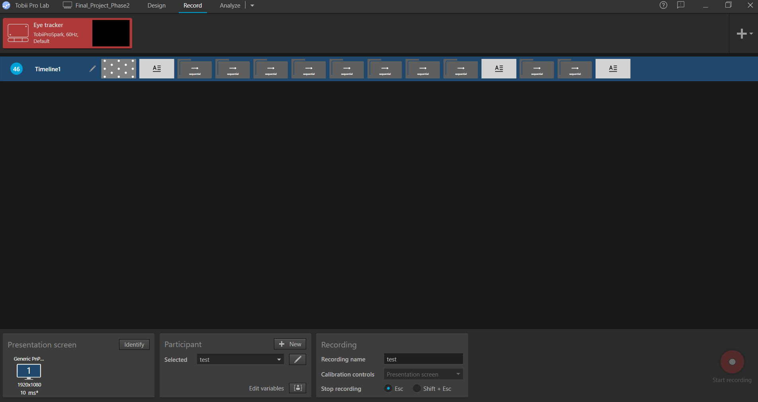



**Fig. 29:** Filling in the participant ID for recording.

After that the participant is ready you need to press "Start Recording".

Once the recordings for all your participants are complete, the collected information can be exported in the form of raw data (as excel or TSV file) you need to go to analyze, then to metrics export, there you can choose a file based on what is relevant to your project, which includes the location and time spent in each predefined area of interest (AOI). This data can include parameters such as the length of time each participant looked at a certain area, the number of visits to each area, and other metrics that can help analyze the patterns of observation.

Choose the appropriate export for your project and analyze it the way you prefer, manually/with software.



**Fig. 30:** Interface for exporting and analyzing the collected and recording data.

Using the software, it is also possible to produce recordings to gain a better understanding of the observation patterns of the participants and use them as a tool for in-depth analysis of the connections between the areas of interest and understanding the behavior of the dogs shown.

# 9. Maintenance Guide

To ensure the smooth operation and accessibility of the experiment, we've prepared a brief maintenance guide detailing how to navigate through the experiment and instructions for transferring an experiment to the user.

## 9.1. Connecting The Device

* + 1. **Connect the Eye Tracker:** Plug the Tobii Eye Tracker cable into a USB port on the computer and connect the other end to the tracking device attached near the screen (the device will magnetically attach).
    2. **Turn on the Device:** Verify that the device is powered on and recognized by the "Tobii Pro Eye Tracker Manager" system.
    3. **Confirm Device Status:** Once activated, the device should display your eye movements on the screen, showing where you are currently looking. Ensure the device is functioning properly before proceeding.

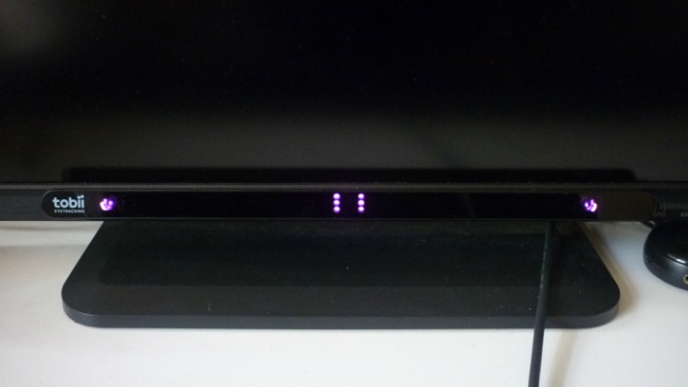

**Fig. 31:** Placing the Tobii Pro Spark under the screen on its part.

**Fig. 32:** Tobii Pro Eye Tracker Manager software.

## 9.2. Calibration And Participants Setup

1. **Participant Positioning:** Seat the participant comfortably at an appropriate distance from the eye tracker, ensuring a stable lighting environment without direct sunlight.
2. **Participant Understanding:** Explain the task clearly to the participant, verifying they understand their role in the experiment.
3. **Calibration:** Begin the calibration process by selecting a calibration target (e.g., a dot). Have the participant follow the target with their eyes as it moves across the screen. Ensure that calibration is accurate by running a test stimulus.

## 9.3. Inputting User Information and Setup for Data Collection

1. **Entering User Information:** Before starting the session, ensure that a unique participant ID is entered into the system (see Fig. 29). This is critical for organizing data and maintaining participant anonymity.
2. **Session Setup:** Load the pre-defined experimental setup for each participant session and ensure that the correct stimuli (images/videos) are prepared according to the experimental design.

## 9.4. Response mechanism and stimulus display

1. **Stimuli Presentation:** The experiment presents participants with visual stimuli (e.g., images and videos) on a computer screen. These stimuli are specifically designed to match the research questions, such as images of dogs in various contexts.
2. **Eye-Tracking:** The eye tracker records the participant's eye movements in real time, capturing gaze patterns that will be analyzed later.
3. **Synchronizing Data:** The system ensures that all stimulus presentation, eye-tracking data, and participant responses are synchronized accurately for data analysis.

## 9.5. Saving Data and Exporting Results

1. **Saving the Session Data:**
   * + - After each session, the collected eye movements should be saved using the Tobii Pro Lab software. Make sure that the information is saved with the participant's unique identification number (participant ID) for proper analysis and maintaining the privacy of the participants.
       - The software allows automatic saving at the end of the experiment. Make sure that this operation is correct and that it is accessible after saving.
2. **Exporting Data:**

* Once the experiment is complete, access the "Analyze" area in the software, and select the "Metrics export" option (see Fig. 33).
* The information can be exported to a variety of formats, including Excel files (.xlsx) or CSV files (.csv), for further processing (see Fig. 30).
* Select the relevant information for export, such as eye movement data (fixations, saccades), gaze points, and response times. It is also possible to export the raw data of the participants (raw data) as well as summary data processed by the software.
* If there is question and answer data recorded outside the system (for example, in Google Forms), it must be manually combined with the eye tracking data to ensure complete data for analysis.

1. **Backup and Storage:**

* After the data is exported, all information must be backed up immediately to avoid data loss. Cloud services (such as Google Drive, Dropbox) or external drives must be used to securely store the data.
* It is recommended to organize the data in an orderly manner according to the participant number and the date of the experiment, to facilitate access to them during the analysis process.



**Fig. 33:** Export data from Tobii Pro Lab.

# 10. Future Work

In the Future Work section, we can focus on expanding the research and highlighting the potential for future experiments using the generic infrastructure we have built. Throughout our study, we make an international framework that allows for significant flexibility in future experiments. The system we choose to work with and google forms is not tailored specifically to our experiment but serves as a general platform that can be used by other researchers. The questions were formulated using Google Forms, making it easy to modify and adapt them for any other experiment. For example, instead of focusing solely on dog images, the images, questions, or even the type of animals (such as cats or monkeys) can be easily replaced while continuing to use the same infrastructure for additional experiments.

Moreover, so far, we have concentrated on static images, but in future research, it will be possible to expand the scope to include participants' responses to videos, enabling a more in-depth analysis of behavior through the movement and dynamics of various animals. In the future, we could conduct a similar study with a larger number of participants to obtain more accurate and robust results. However, due to the time constraints we faced in this study, we were limited in the number of participants we were able to include.

In this way, the infrastructure we make provides a versatile tool for researchers from different fields to explore human responses, emotions, and behaviors in relation to various animals across a range of contexts. This investment in a flexible and generic framework can lead to large-scale studies with numerous research applications, and we see significant potential in further international collaborations based on the platform we created.

Our research has garnered significant attention and interest from leading researchers at the University of Prague, as well as from Professor Anna Zamansky of the University of Haifa, who expressed enthusiasm about the methodology and findings. As a result, the researchers from Prague have shown interest in future collaboration to expand the study and apply it in additional contexts. These positive responses underscore the potential and importance of this research in the field, opening up exciting opportunities for further development and deeper exploration of the topic.

In future research, we aim to explore several new hypotheses that build upon the current findings. First, we hypothesize that people will increasingly rely on different body parts when interpreting interactions with dogs, particularly when facial areas provide less informative cues (H1). This could help refine our understanding of which visual elements participants prioritize in more complex or ambiguous contexts. Additionally, we believe that owners of brachycephalic dogs may have an advantage in recognizing visual cues compared to owners of normocephalic dogs, given their frequent exposure and familiarity with the unique facial structures of these dogs (H2). Lastly, we expect that participants will spend more time watching videos of brachycephalic dogs, due to the difficulty in interpreting their emotions, leading to a focus on areas that are perceived to offer more suggestive cues (H8).

# 11. Appendix



# References

1. Bloom, T., & Friedman, H. (2013). Classifying dogs’(Canis familiaris) facial expressions from photographs. *Behavioural processes*, *96*, 1-10.‏
2. Correia-Caeiro, C., Guo, K., & Mills, D. S. (2020). Perception of dynamic facial expressions of emotion between dogs and humans. *Animal cognition*, *23*(3), 465-476.‏
3. Correia‐Caeiro, C., Lawrence, A., Abdelrahman, A., Guo, K., & Mills, D. (2023). How do children view and categorise human and dog facial expressions?. Developmental Science, 26(3), e13332.‏
4. Eretová, P., Liu, Q., Přibylová, L., Chaloupková, H., Bakos, V., Lenkei, R., & Pongrácz, P. (2024). Can my human read my flat face? The curious case of understanding the contextual cues of extremely brachycephalic dogs. Applied Animal Behaviour Science, 270, 106134.‏
5. Guo, K., & Shaw, H. (2015). Face in profile view reduces perceived facial expression intensity: an eye-tracking study. *Acta psychologica*, *155*, 19-28.
6. Liu, W., Trapp, A. C., & Djamasbi, S. (2021). Outlier-Aware, density-Based gaze fixation identification. Omega, 102, 102298.‏
7. Sæther, L., Van Belle, W., Laeng, B., Brennen, T., & Øvervoll, M. (2009). Anchoring gaze when categorizing faces’ sex: evidence from eye-tracking data. *Vision research*, *49*(23), 2870-2880.

1. <https://www.oakhill-vets.com/small/brachycephalic-dog/>
2. <https://www.tobii.com/products/eye-trackers/screen-based/tobii-pro-spark>